MOTIVATION
Computer science is the study of computers. But before the students can learn about computer science, they need to explore a few important questions: What exactly is a computer? What is it made of? How does it work? This unit will help address these questions and build a foundational understanding of computers to prepare students for the units to come.
OBJECTIVES
Students will be able to:
- Consider what it means to be a computer
- Decide whether or not an object is a computer
- Understand the basic functions of hardware
- Distinguish software from hardware
- Understand that software uses hardware in different ways to accomplish specific tasks
RESOURCES
Day 1: What Defines a Computer
Lesson Plan ( Source / PDF )
Activity 1: Is This a Computer? ( Source / PDF )
Activity 2: Debating Computers ( Source / PDF )
Activity 3: What Defines a Computer? (Source / PDF )

Day 2: What's in a Computer?
Lesson Plan Day 2 (Source / PDF )
Lesson 1: Meet Team Hardware (Source)
Activity 1: Hardware Experts Exercise (Source / PDF)
Activity 2: PB & J Computer Handout (Source / PDF)
Instructor's Handout (Source / PDF)

What Defines a Computer?
Welcome to "What Defines a Computer!"
OBJECTIVES
- Students will briefly learn about the first computer, ENIAC.
- Students will try to decide what types of objects are computers and what are not computers.
- Students will define what it means to be a computer.
SAMPLE AGENDA
- Read about ENIAC and watch the introductory video "What is a Computer?"
- Complete Activity 1: Is This a Computer? ( Source / PDF )
- Debrief Activity 1
- Complete Activity 2a: Post-it Parade ( Source / PDF )
- Or, complete Activity 2b: Debating Computers ( Source / PDF )
- Talk about the Discussion Questions
- Complete Activity 3: What Defines a Computer? (Source / PDF )
- Talk about the Discussion Questions
MOTIVATING CONTEXT
The first electronic computer, ENIAC, was created about 70 years ago, between the years 1943 and 1946. It was able to perform multiplication, division, addition, subtraction, and square root operations, but ran much more slowly than computers today. It was the size of a two-car garage and weighed approximately 27 tons.

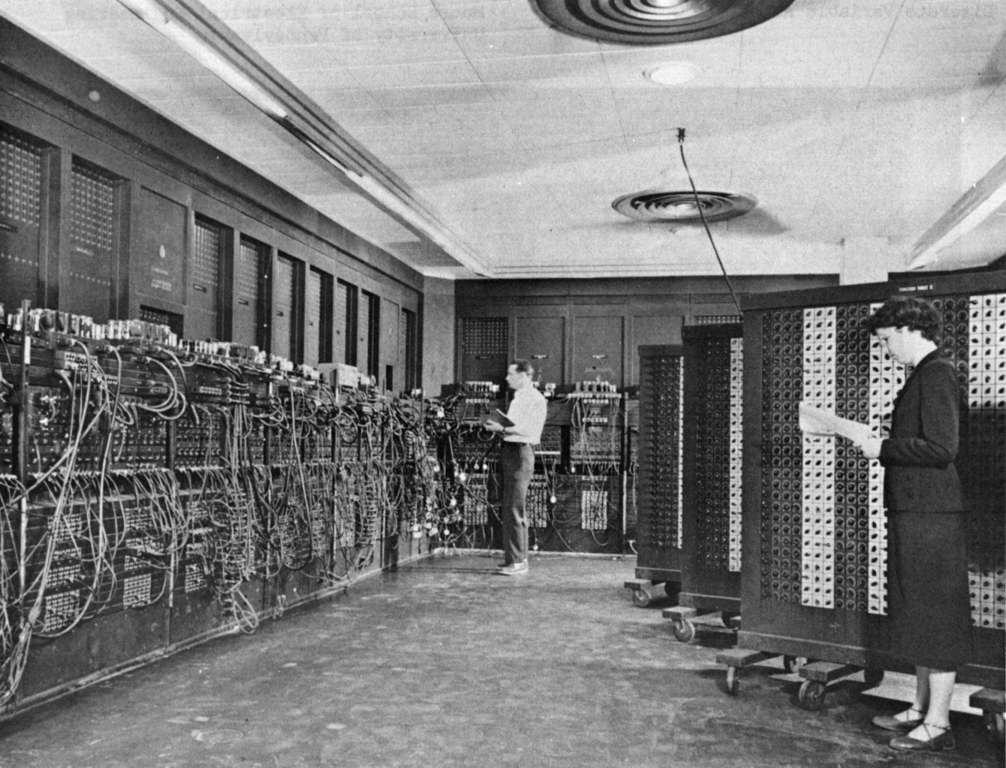
Source: Wikimedia Commons

Since ENIAC, computers have gotten smaller, faster, cheaper, and more complex than ever before. The idea that every family could have a computer was unheard of to people 40 years ago. Today, it is almost a reality.
Because the computer changes so rapidly, it is interesting to consider what exactly makes a computer a computer. Does it have to look like modern-day desktop or laptop computers, or can it be something else? What other things can perform computations? What counts as a computation?
Answering these questions can be challenging, but thinking about them gives us a great way to start thinking about how computers work. The video below provides some starting points for discussion.
INTRO VIDEO: WHAT IS A COMPUTER?

ACTIVITY INTRODUCTION
In the video you just watched, you learned that smartphones and printers can be considered to be computers.
Can you think of any more objects around you that you think are computers?
The video also discussed computer parts such as the "CPU" and "hardware." We will talk about these parts in more detail in the next section. For now, do not worry if you do not know what these parts are.
ACTIVITY: IS THIS A COMPUTER?
In the Is This A Computer activity you will decide wether or not six different objects are computers or not. Click the link above or the picture below to get started.
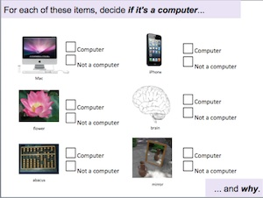

ACTIVITY: RANKING COMPUTER-NESS
In the this activity activity, you will work in groups to place a list of items on the spectrum based on how strongly you believe that each item is a computer. Click on the link above or the picture below to get started!

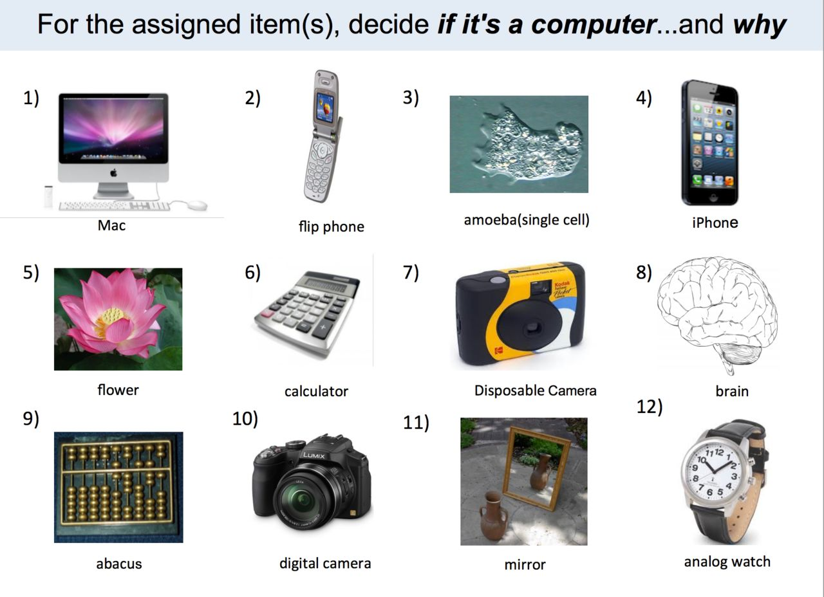

ACTIVITY DEBRIEF
Which objects did the majority of people think were computers?
Which objects did the majority of people think were not computers?
Were some objects difficult to decide on? Why?

ACTIVITY: DEBATING COMPUTERS
First, split into groups of about 4 students. In the Debating Computers activity, each group of students will have a piece of paper with a statement at the top declaring some object to be a computer.
- The first student writes down a short explanation of why this statement is true on the left side of the page and then passes the paper to the second student.
- The second student writes an argument for why the statement is false on the right side of the page and passes the paper to the third student.
- The third student makes a rebuttal to the first student's claim, explaining why they might disagree with that first person and passes the paper to the fourth person.
- The fourth person makes a rebuttal to the second person's claim.
- The class comes together to share what each group wrote.
More detailed directions can be found on the activity handout. Click the link above or the picture below to get started.

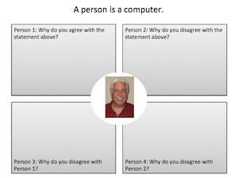

DISCUSSION QUESTIONS
Were there any common arguments in support of the objects being computers? If so, what were these arguments?
Were there any common arguments in support of the objects not being computers? If so, what were these arguments?
ACTIVITY: WHAT DEFINES A COMPUTER?
In the What Defines a Computer activity, you will use the knowledge you've gained in the past two activities to come up with the definition of a computer. Click on the link above or the picture below to get started!

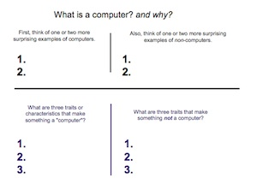

DISCUSSION QUESTIONS
How was your definition of a computer different from the definitions of other students?
How was your definition of a computer similar to the definitions of other students?
What are some of the common traits shared by most people's definitions of a computer?
DAY 1 WRAP-UP
Many of the things that we interact with every day can be considered computers. In fact, smart phones, dishwashers, cells, brains, and people could all be considered computers, depending on what definition of "computer" you use. The following video may help you think about the differences and similarities between people and computers.
VIDEO: WRAP-UP: SIMULATING THE BRAIN WITH A COMPUTER

VIDEO DISCUSSION
Do you think that downloading the content of a human brain onto a computer will be possible in your lifetime?
If you downloaded your brain onto a computer, would you still be a person?
What are the differences between people and computers? What are the similarities?

Hardware & Software
OBJECTIVES
In this lesson, students will learn the basics of how computers work. Computers combine hardware, or a collection of devices to store, change, and display data, and software, which provides instructions for the hardware to follow. Students will begin to understand how software and hardware interact to create what they experience when they use a computer.
SAMPLE AGENDA
- Watch "Inside Your Computer" video
- Meet Team Hardware (Source)
- Activity: Hardware Experts (Source / PDF)
- Discussion: What is Software?
- Activity: PB & J Computer Handout (Source / PDF)
Instructor's Handout (Source / PDF)
- PB & J Computer Debrief
MOTIVATION AND CONTEXT
Computers have become a very important tool in just about every industry. But what actually goes on inside a computer? We will explore this today by learning about the different parts that go into computers (hardware), and some of the ways people program those parts to make them function the way we want them to (software).
VIDEO: INSIDE YOUR COMPUTER

MEET TEAM HARDWARE
Now we are going to meet our team of secret agents: Team Hardware. Each member of the team is an expert in its field. By splitting projects up into specialized tasks that are assigned to the corresponding expert agent, the team is able to work together to solve difficult problems and perform impressive tasks.
Normally, the team stays inside their Secret HeadQuarters during operations. They have agreed to come out of HQ (aka the Computer Tower) for today to teach you more about the inner workings of a computer. They still must maintain their secret identities though, so they are all wearing expertly designed disguises.

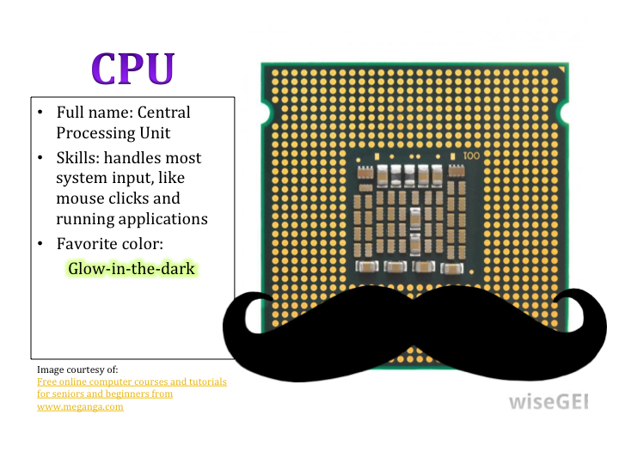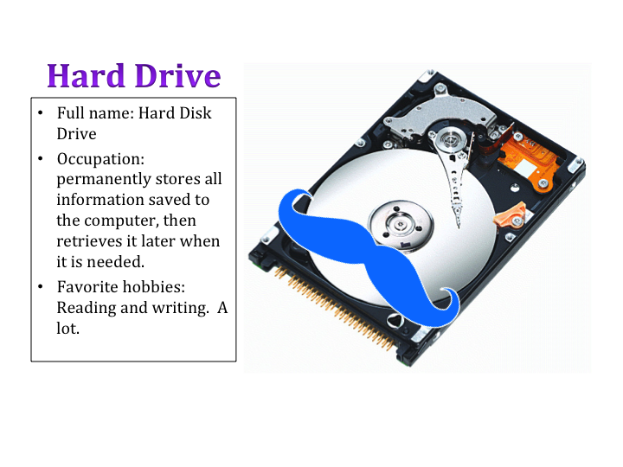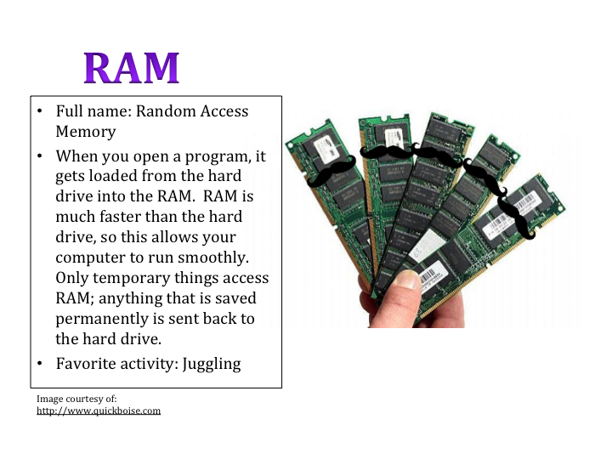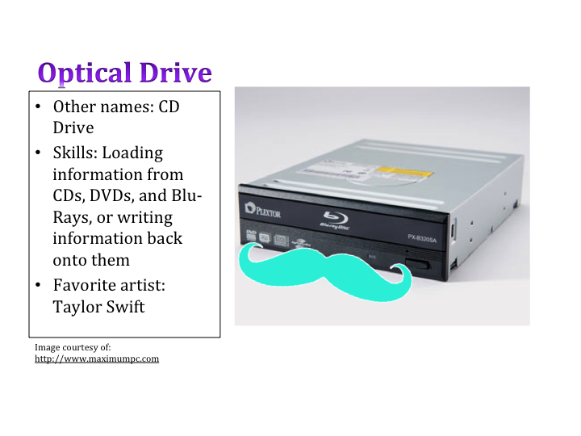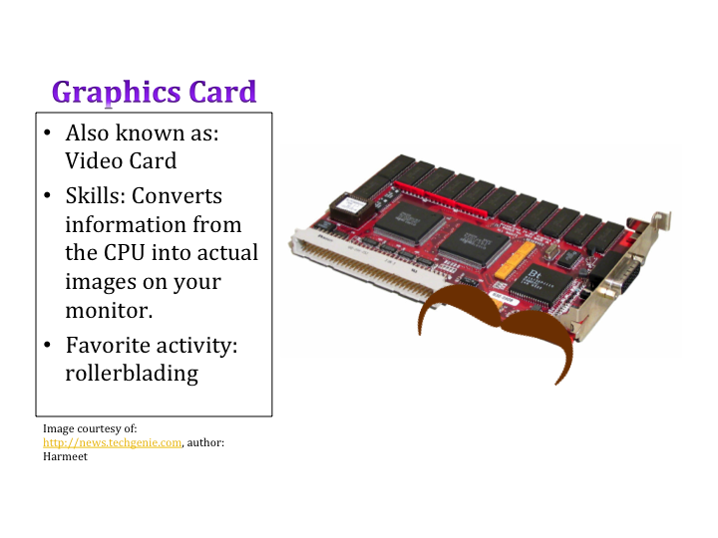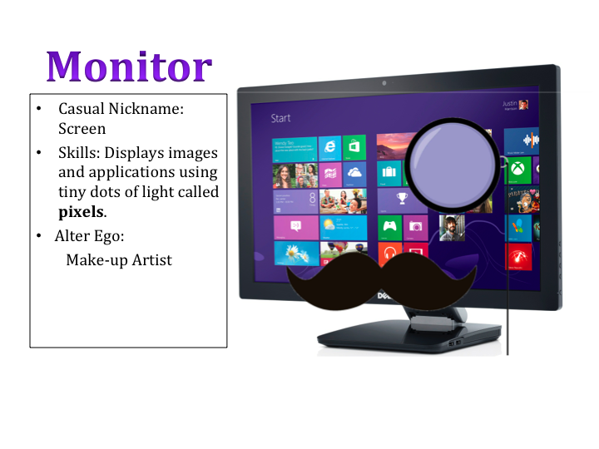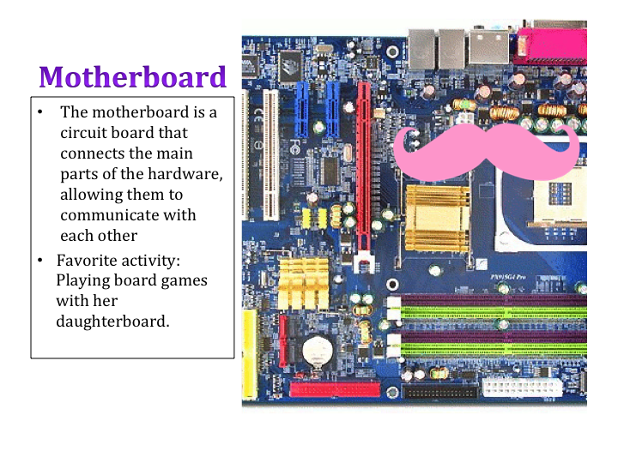
ACTIVITY: HARDWARE EXPERT
Now that you've met Team Hardware, you are a Hardware Expert. The team needs you to use your new expert skills to help them solve a few cases. Click the link here to get started, or click on the picture below.
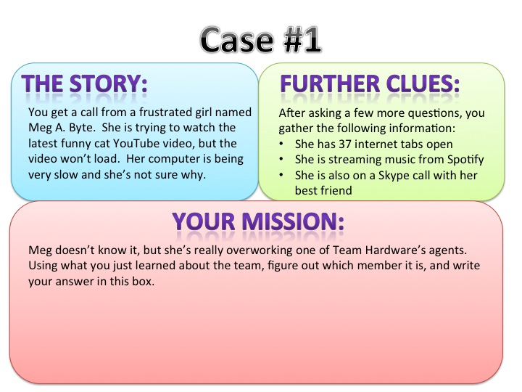
DISCUSSION: WHAT IS SOFTWARE?
Remember those Team Hardware agents? Each of them is specialized in a field, but all of them must work together to make a functional computer: to store and display information.
As with any team, the agents need instructions on how to work together and accomplish their part of the task. The software in a computer tells the Team Hardware agents how to store and display information by providing each agent with a set of instructions.
Most of the computer programs you are familiar with all use the same Team Hardware agents, but give them different instructions.
Can you think of some software programs that you use?

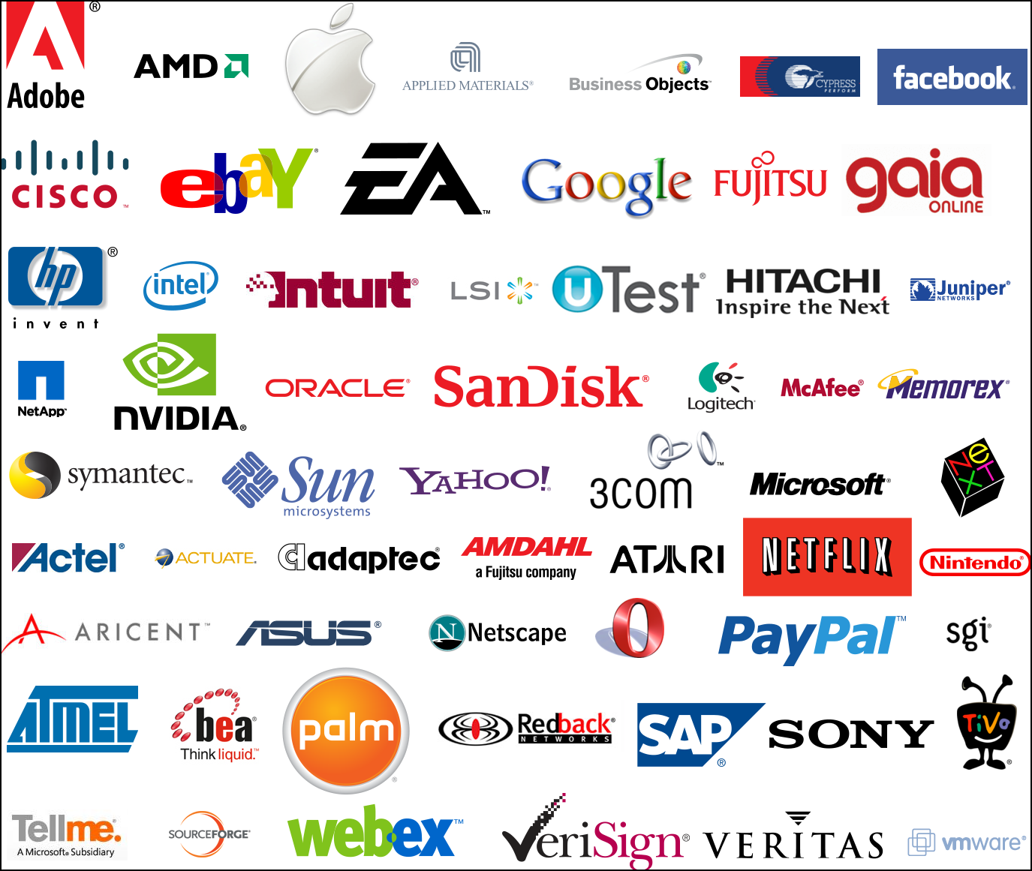

Your computer probably runs on an operating system, like Windows or Maverick. Operating systems are a type of software that manage the basic operations of a computer, as well as determine how you can interact with the computer. They provide a framework for other software.
If you've played a game, used a web browser like Internet Explorer or Mozilla Firefox, written an essay in Microsoft Word, or played music in iTunes, you've used software!
The apps on a phone are also pieces of software: games, e-mail, to-do lists, calendars, even basic alarm systems and timers.
Software can also be undesirable! Computer viruses are software programs that give the Team Hardware agents bad instructions.
Software and hardware must work together to create a functional computer.
ACTIVITY: PB&J COMPUTER
We have a PB&J computer that makes peanut butter and jelly sandwiches. Here's some of the hardware:
- A jarof peanut butter
- A jar of jelly
- A loaf of bread
- A butter knife
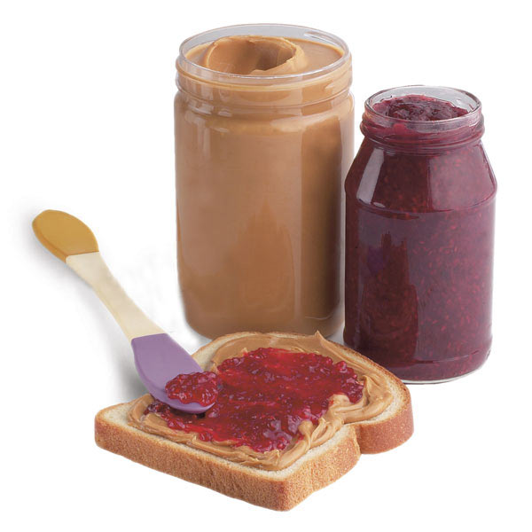
However, this computer is missing its software! Your task is to program this computer to make a PB&J sandwich. In other words, create a set of instructions for making a PB&J sandwich.
Which Team Hardware agents will you use? What will you tell them to do?
You can follow along on the PB&J Computer handout, linked via the image below:

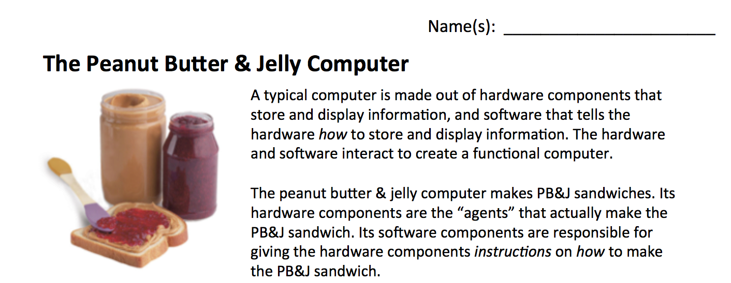

PB&J ACTIVITY DEBRIEF
Did your instructions work? Why or why not?
Did you leave out any details you should have included? What kinds of details did you leave out?
What kinds of instructions are easier for humans to carry out than computers? Why?

