MOTIVATION
Both humans and computers possess the power of computation, but they "think" differently. In this unit we will explore what it means for something to be "intelligent," and discuss whether or not it is possible for a computer to possess human intelligence.
OBJECTIVES
Students will:
- explore different examples of artificial intelligence
- know what the Turing Test is and how it works
- Be able to identify key differences between humans and computers
RESOURCES
Artificial Intelligence Lesson Plan: ( Source / PDF )
Artificial Intelligence Activity: 20 Questions
Turing Test Lesson Plan: ( Source / PDF )
Turing Test Activity: List of Questions ( Source / PDF ), List of Computer Answers ( Source / PDF )
Turing Test Chatbots Activity: Eliza, CleverBot, Jabberwacky, A.L.I.C.E.

Artifical Intelligence
In this segment, we discuss what artificial intelligence is and begin to explore the idea of what it means to be intelligent.
OBJECTIVES
- Expose students to some examples of artificial intelligence
- Discuss what it means for somthing to be intelligent
SAMPLE AGENDA
- Watch the motivational video and have a class discussion about it
- Have students complete the 20 Questions activity
- Discuss the intelligence of the 20 Questions computer the students played against.
- Watch the "Realistic Artificial Intelligence" video and discuss it as a class
- Bonus: Watch the "Humans and Computers Working Together" video
VIDEO: MOTIVATION: WHAT IS ARTIFICIAL INTELLIGENCE?

VIDEO DISCUSSION QUESTIONS
How closely must a computer resemble a human for the computer to be considered intelligent?
Do you think it is possible for computers to become more intelligent than people?
Why might it be relatively easy for computers to become masters at chess while struggling with human vision and language?

ACTIVITY: TWENTY QUESTIONS
In this activity you will play a few games of 20 questions against a computer. The computer will ask you questions and then will try to figure out what you are thinking of. This is an example of very basic artificial intelligence.
To get started go to 20q.net. Choose your language ("Think in American" is recommended), and choose an object you want the computer to guess. Answer the questions and see if the computer guesses your object!
ACTIVITY QUESTIONS
Did the computer guess your object? If so, how many questions did it take to guess your object?
How intelligent is this game of 20 Questions?
VIDEO: REALISTIC ARTIFICIAL INTELLIGENCE

WRAP UP DISCUSSION
Do you think Philip, the robot, is intelligent? Why or why not?
How would you decide whether or not a computer was intelligent?
BONUS VIDEO: HUMANS AND COMPUTERS WORKING TOGETHER

The Turing Test
At the end of the last lesson on artificial intelligence you discussed how to decide whether a computer is "intelligent" or not. Today, we will discuss a test known as the Turing Test to determine whether or not a machine can be considered intelligent.

OBJECTIVES
- Students should understand what the Turing Test is and how it works
- Students should understand how the Turing Test relates to intelligence
- Students should be able to give a few basic human abilities that computers find very difficult to replicate
SAMPLE AGENDA
- Watch the Turing Test video and discuss what the Turing Test is as a class
- Complete Activity 1: Human or Computer
- Introduce, explain, and complete Activity 2: The Turing Test. Materials: List of Questions ( Source / PDF ), List of Computer Answers ( Source / PDF )
- Introduce the Loebner Prize
- Complete Activity 3: Chatbots
- Discuss the Wrap Up material
- Watch the "Chatbots Conversing" video
VIDEO: ALAN TURING & CODEBREAKING

THE TURING TEST: MORE DETAIL
Alan Turing (1912-1954) was an English mathematician and computer scientist. He worked on some of the first computers and was a pioneer in the fields of theoretical computer science, cryptography, and artificial intelligence.
In 1950, Turing wrote a paper asking the question: "Can machines think?" He proposed a thought experiment where a judge, a human, and a computer are all placed in seperate rooms. The judge converses with the human and with the computer without knowing which entity is the human and which is the computer. The judge then must decide who is the computer and who is the human. If the computer can successfully impersonate a human to the point where the judge cannot tell who is the human and who is the computer, then the computer is considered "intelligent."
Today we call this test the Turing Test. So far, most computer scientists agree that no computer has managed to pass the Turing Test.
THINKING ABOUT THE TURING TEST
One of the great questions in computer science is wether or not a machine is capable of simulating human intelligence. However, in order to answer this question, we must first define what it means for something to be intelligent. The Turing Test is the most accepted standard for what it means to be intelligent. However, many philosophers argue that if a machine passed the Turing Test this merely means the machine can just immitate human intelligence, not necessarily that the machine is a truly intelligent being.
Do you think the Turing Test is an adequate standard for intelligence?
Can a computer be intelligent without having emotions, without being self-conscious, and without being alive?
Is it possible that a human brain is merely a machine running a very elaborate computer program?
ACTIVITY 1: HUMAN OR COMPUTER?
As you just learned, a machine is considered intelligent if a human cannot tell whether the machine is a human or a computer. Look at the conversation below and try to figure out whether the it is between 2 humans or a human and a computer

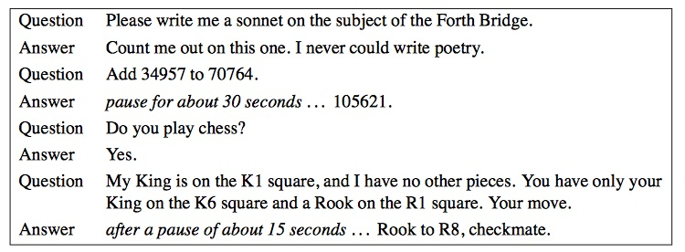

Do you think the being answering the questions is a human or a computer? Why?
What makes human responses different from computer responses?
ACTIVITY 2 INTRO
In this activity, you will carry out a miniature Turing Test.
Directions: Choose one person from the class to be the computer and another person to be the human. Have these 2 people leave the classroom. Choose 2 more people to be messengers. Then, have the rest of the class pick a question off the allowed list of questions. One messenger will go ask the human the question chosen by the class while the second messenger will go ask the computer the question chosen by the class. The person playing the computer must answer the question by reading the provided answer listed under the given question on the computer answers sheet. The two messengers then return and report the answers to the class without telling the class if the answer came from the computer or from the human. The class will discuss the answers and ask a few more questions until they can determine which messenger is representing the computer and which messenger is representing the human.
Pre-Activity Questions:
What questions can an intelligent human answer that a computer cannot?
What type of question might be good at helping distingish between a human and a computer?
ACTIVITY 2: THE TURING TEST
Everyone in the class should have a copy of the acceptable questions and the person playing the computer should have the list of acceptable computer answers to the questions.
Pick a computer, a human, and 2 messengers and get started!

TURING TEST ACTIVITY DISCUSSION
What gave away the computer? Did it complete calculations that would be very difficult for a human to complete quickly? Were any of its answers formulaic? Did it ever seem to misinterpret or not know how to answer a very basic question?
What was different between the computer answers and the human answers?
Did the computer ever try to trick you into thinking it was a human?
ACTIVITY 2 INTRO: THE LOEBNER PRIZE
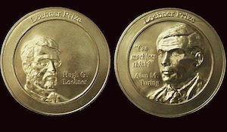
The Loebner Prize was created in 1991 and is designed to reward anyone who can create a machine, also known as a chatbot, that passes the Turing Test. At an annual competition, judges evaluate chatbot submissions and determine how well these machines simulate human interaction.
If the judges cannot distinguish between the chatbot and a human responder, the creator of the chatbot will win the Loebner Prize. Multiple versions of the prize exist: the silver prize goes to the first text-based chatterbot that passes the Turing Test, and the gold prize goes to the first machine to respond to text, sound, and visual input in a way indistinguishable from a human. The annual competition will stop occurring after someone wins the gold prize.
So far, nobody has won the silver or the gold Loebner Prize. In this next activity you will interact with some chatbots and decide if you think they should pass the Turing Test!

ACTIVITY 2: CHATBOTS
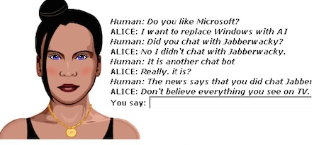
Have a conversation with all or some of the chatbots listed below. See if you can ask the chatbot questions that obviously reveal that the chatbot is a computer, not a human.
Eliza
CleverBot
Jabberwacky
A.L.I.C.E.
ACTIVITY 2 WRAP UP
In your opinion, do any of these chatbots pass the Turing Test?
What questions confused the chatbots?
Which chatbots seemed the most like humans? Which seemed the least like humans?
What were some similarities between the chatbots? What were some differences?
TURING TEST WRAP UP
Today we have learned that it can be very difficult for a computer to simulate human intelligence. Things humans find second nature, such as speaking, understanding a language, and seeing are all very difficult tasks for a computer. So far, one of the best chatbot fooled 59% of the judges, and these judges only thought that 64% of the humans were humans!

