Beginning Motion in Scratch
Section B: Part 1: Day 1: Beginning Motion in Scratch.
This unit begins the Scratch portion of MyCS, teaching basic 2D motion and the use of the "Repeat" block.
https://docs.google.com/document/d/1UZChXh_VPKdGEXIgd-3c7TxIlmgqatIDolp4HsoQ5Jw/edit?usp=sharing
Beginning Motion Lesson Plan
Scratch World 01: Ocean

MOTIVATION AND CONTEXT
- Scratch is an online programming language created by MIT to teach the basic concepts of Computer Science to grade-school students. It involves dragging blocks and connecting them to control objects called sprites.
- Motion is one of the fundamental starting points in Scratch. By manuvering the sprite through mazes students learn how to use the basic blocks in Scratch.
Lesson Plan for Section B: Part 1: Day 1
VIDEO: SCRATCH

ACTIVITY SETUP
  - Once everyone has "1.1 One Direction" open, create the sequence of blocks illustrated below and press the green flag to see this script run.
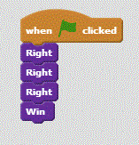
- Note that it has to have the "Win" block at the end to check if it is reached the end.
- If they do not reach the end, click the "Reset" block in the block menu to send the sprite back to the start.
Question:
What block is needed to check if the route is correct?
(“Win”—By placing the "Win" block at the end of your code, your sprite can check to see if it has ended where it should. If it does, it will do a little dance, but if it doesn't you should click "reset" and try again.)

ACTIVITY PART 1
- Using the "Up", "Down", "Left", and "Right" blocks do levels 1.2, 1.3, 1.4, and 1.5.
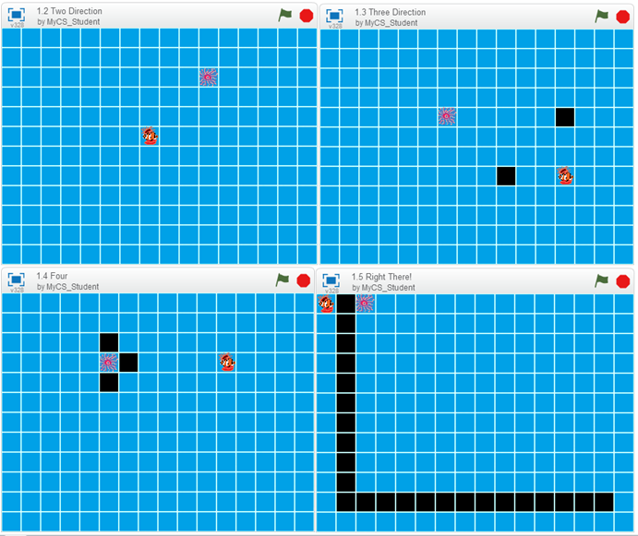
Lesson Plan for Section B: Part 1: Day 1
REPEATING
- Write the following code for "1.6 5x3".
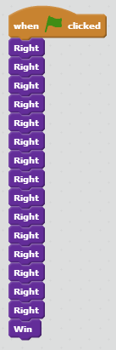
- Note how it is incredibly long, so you can write the code below to do the exact same thing.
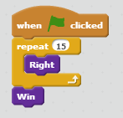
- The "Repeat" block allows anything inside to be repeated a certain number of times before going on. This makes the code a lot shorter.
ACTIVITY PART 2
- Using "Up", "Down", "Left", "Right", and "Repeat" blocks, do levels 1.7, 1.8, 1.9, and 1.10.

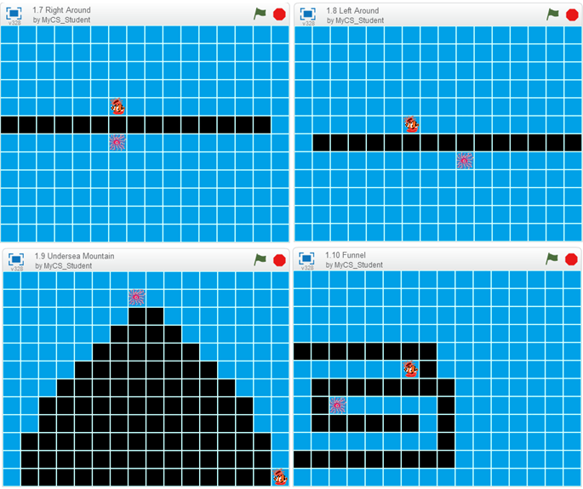
REFLECTION
- Notice how the "Repeat" block makes the scripts considerably shorter than before.
- This basic command can be used to maneuver any sprite in Scratch. It will continue to be a fundamental piece in the rest of the puzzles.
APPLICATION OF MOTION
- This classic type of 2D motion was the foundation of classic video games and is still important in games like Pokemon, Legend of Zelda, and Animal Crossing.
The simple four directions are the easiest ways to have a character move through a maze.

Build Your Own Maze in Scratch: Part I
OBJECTIVE
This unit allows students to create their own maze in Scratch using a template.
USEFUL LINKS
https://docs.google.com/document/d/1ohn2pCa-YSJoNEPU2Jm4k9m6c3YzIcQ1gXdQxMCKQVU/edit?usp=sharing
Building Mazes in Scratch I Lesson Plan
Scratch World 00: Part 1 Day 2 Template
MOTIVATION AND CONTEXT
- After working through all the puzzles in World 01 you should have a grasp of the basic concepts of motion as well as what makes an interesting puzzle.
- This section focuses on the creation of individual puzzles and sprites. Using the tools and given icons you will be able to create your own unique maze.
Section B: Part 1: Day 2 Lesson Plan
ACTIVITY SETUP
- Have everyone get to World 00: Part 1 Day 2 Template.
- Your screen should look like this. If it does you are ready to make your own puzzle.

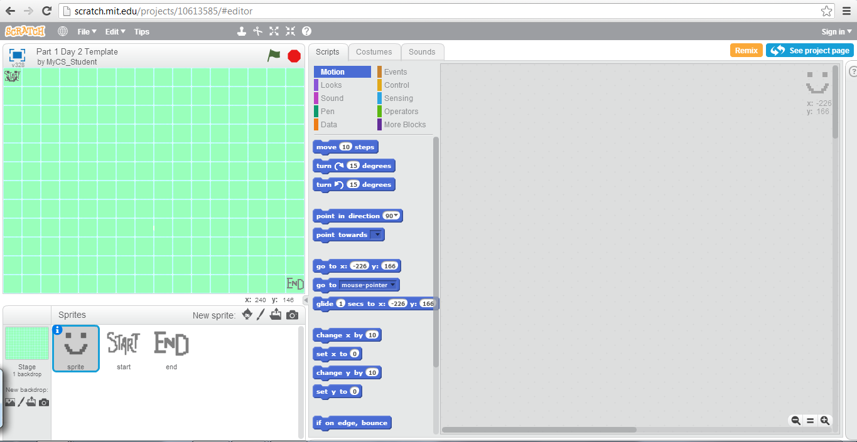

Section B: Part 1: Day 2 Lesson Plan
ACTIVITY PART 1
- Select "sprite" and then click on the "Costumes" tab at the top of the screen. From here you can either use a premade sprite (the first icon under "New costume:"), paint your own sprite (second icon), or upload one from you computer (third icon).
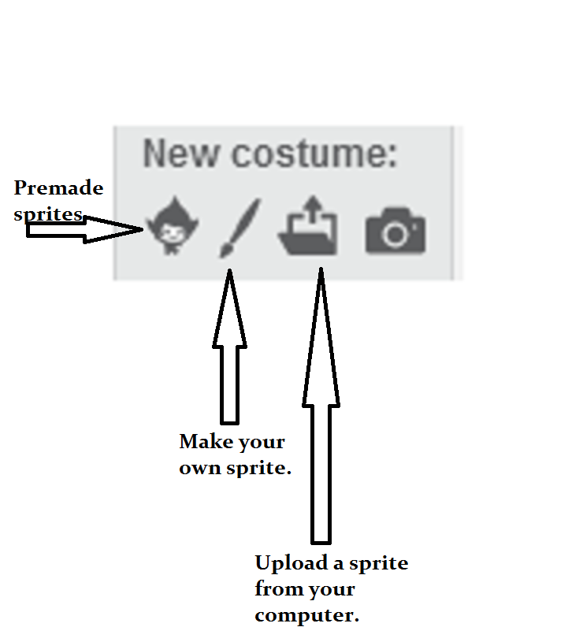

- These are the paint tools (if you can't see them click "convert to bitmap mode"
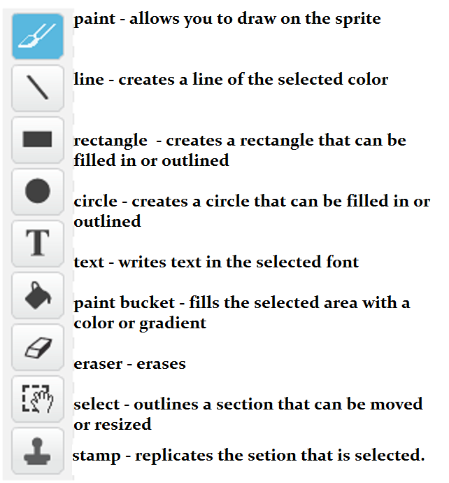

- Make a new costume for "sprite", "start", and "end".
- Feel free to click and drag the sprites to new squares on the grid. When you click "Reset" (under More Blocks in the Scripts tab), sprite will go to the start.
Section B: Part 1: Day 2 Lesson Plan
REFLECTION PART 1
- Using all of these tools allows for customization. This type of editing is fundamental in digital design.
- These sprites add a personal aspect to the game, but it isn't challenging if there are no walls to the maze.
ACTIVITY PART 2
- Select "Stage" on the left of your screen and click on the tab labled "Backdrops".
- Using the paint bucket tool, color some of the squares black to create walls for the maze.
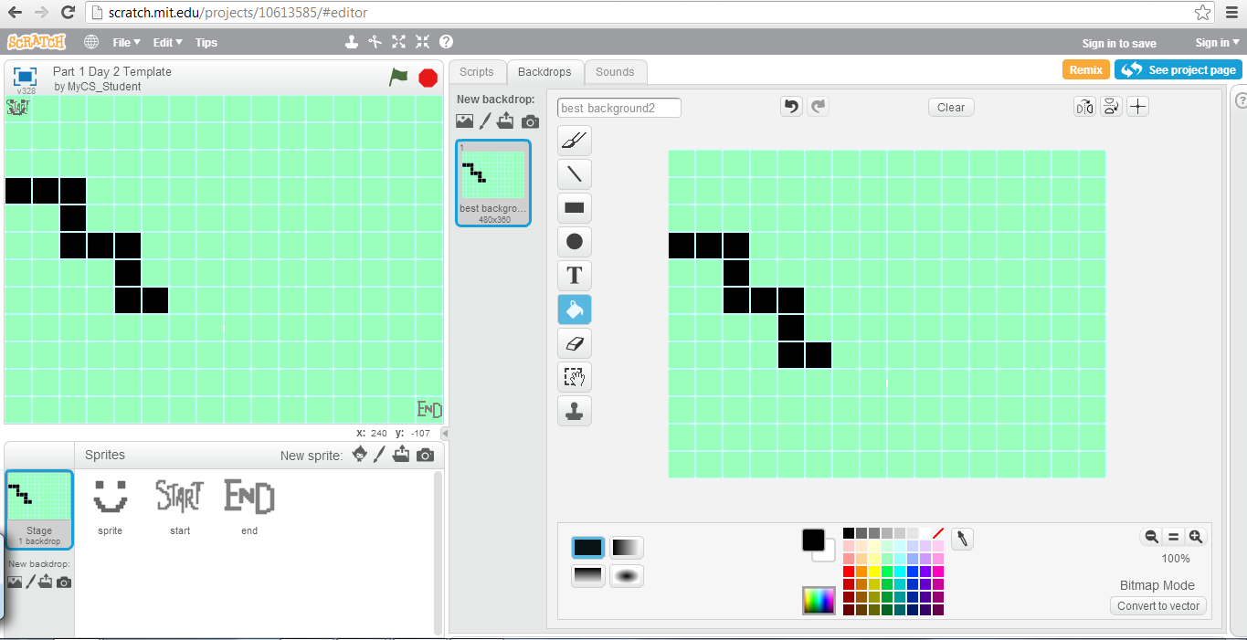

- Feel free to color the rest of squares any other color besides black to create a unique background.
Section B: Part 1: Day 2 Lesson Plan
REFLECTION PART 2
- By creating your own sprites and background, you can create a unique puzzle that you can save on Scratch and share with others.
- These coloring skills will apply to any maze that you build in Scratch using these templates.
APPLICATION OF MAZE CREATION
- Mazes are the foundation of the majority of video game levels. The layout can be represented two-dimentionally, similarly to the mazes that you created.
- Sprites in Scratch are the interactive pieces. By making the sprite, you are creating your own hero to go through the maze. The start and end are the locations that you create and move to make your own universe.
Though this is a simple game, it has the same fundamentals as many classic and modern video games.

Enter the Villain
DESCRIPTION
This unit continues working through the concepts of Computer Science. It particularly focuses on the "Wait" block in relation to other moving pieces on the Puzzle.
old https://docs.google.com/document/d/1QC1BDR7DR9xXb2Y2KSc9mv1at3Hl1xTk4Mrz354ZR7s/edit?usp=sharing
LINKS
Enter the Villain Lesson Plan
Scratch World 02: Safari
MOTIVATION AND CONTEXT
- When it comes to interactions of any kind, timing is important. In this case, the timing of your character's position versus the lions is essential, as well as moving out of harm's way, even if it takes you farther away from your goal.
- These interactions can be described as parallel, since the lions are moving at the same time as your character. Yet all of the code that controls the sprite is linear, going step by step.
Lesson Plan for Section B: Part 1: Day 3

Question:
What block is effective in interactions between sprites?

(“Wait” –The "wait" block is the most effective of the interactions with sprites such the lions in World 02. By waiting for them to pass you can safely traverse the rest of the maze.)

ACTIVITY SETUP
- Once everyone is in "2.1 Don't get eaten!" then create the sequece of blocks illustrated below and press the green flag to see the script run.
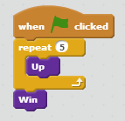
- Notice that the elephant gets eaten using this code. Now try using a "Wait" block.
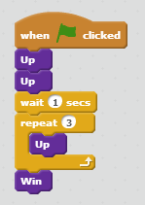
- Since the elephant waits for the lion to pass it is safe to make it to the end. If it does not reach the end, click the "Reset" block to send the sprite back to the start.
ACTIVITY PART 1
- Using the "Wait" block, solve levels 2.2, 2.3, 2.4, and 2.5.
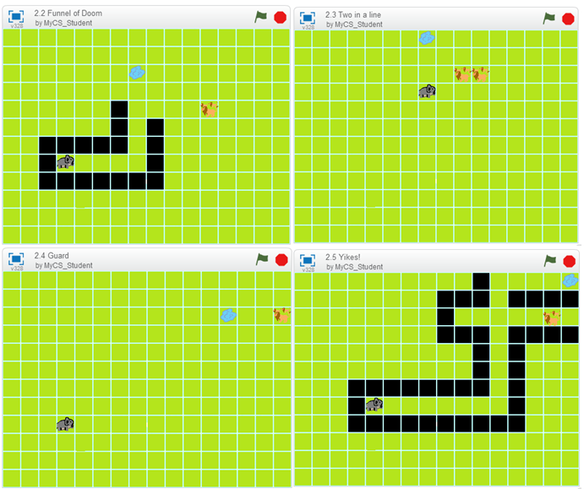

Lesson Plan for Section B: Part 1: Day 3
REFLECTION PART 1
- Write the following code for "2.6 But three's a crowd"
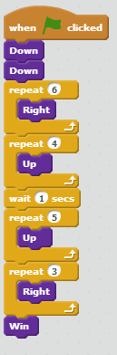
- Notice how it has to go down first to avoid the lion. The next four levels involve moving counter-intuitively as well as waiting to get to the end.
Section B: Part 1: Day 3 Lesson Plan
ACTIVITY PART 2
- Using "Wait" as well as moving to avoid the lions, complete levels 2.7, 2.8, 2.9, and 2.10.
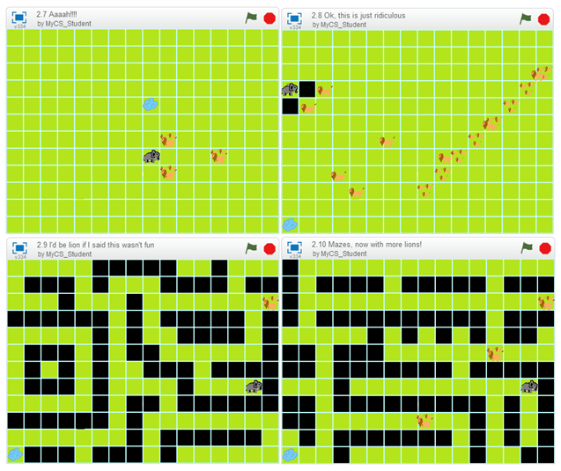
REFLECTION PART 2
- In this section we had to clearly plan out the path before implementing it. By thinking through the motion that the sprite would have to accomplish in relation to the lions, you developed skills about the interaction of programs.
It's this concept of interaction that makes this unit so important. All of the sprites in Scratch run at the same time unless told otherwise. The easiest way to control when a sprite moves is by having it wait until some other action is performed.

Sensing, Conditionals, and Colored Portals
DESCRIPTION
This unit focuses on the use of sensing and conditional statements to traverse through portals in each level. Sensing is when a sprite knows when it is touching a certain color. Conditional statements are "if-then" statements, allowing for something to happen only if a certain critera is met.
LINKS
https://docs.google.com/document/d/1FT5g9TKIphdb03r35Aff65mK9CXYllAbuXfWMAaxaIc/edit?usp=sharing
Sensing and Conditionals Lesson Plan
Scratch World 03: Fire
MOTIVATION AND CONTEXT
- Conditional statements are fundamental parts of logic. The concept of "if A is true, then B happens" is the focus of this level.
- Computers follow conditionals. If the "A" key is pressed, an "A" is typed on the screen. If the battery is low, a message is put on the screen saying so. These rules are constant in the program, only running if the starting condition is met.
Section B: Part 1: Day 4 Lesson Plan
ACTIVITY SETUP
- Once everyone is in "3.1 Trapped?" then create the sequence of blocks illustrated below and press the green flag to see the script run.
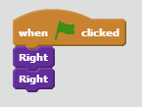
- Notice that when the sprite reaches the portal, it can go to both lit candles (feel free to reset and run it a few times to see it land on either candle). Conditionals and sensing allow the sprite to know what to do when it is touching a specific color.
- Now try the following code. The "if then, else" block is in the Control category of scripts, and the "touching color" block is in the Sensing category. You can choose the color by first clicking the small square of color in the block, then clicking an area on your screen that has the color you want to select.
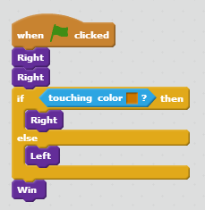
- Notice how it goes right when it is touching the orange after teleporting, but goes left otherwise. Since the "Win" block is after both conditions it runs after the conditional.
Section B: Part 1: Day 4 Lesson Plan
ACTIVITY PART 1
- Using the "if then, else" and "touching color" blocks, solve levels 3.2, 3.3, 3.4, and 3.5.
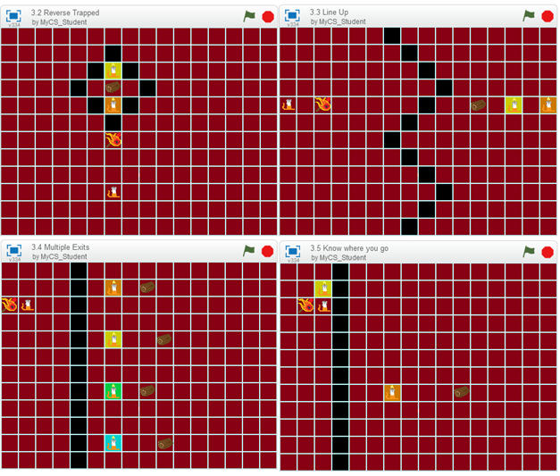
Section B: Part 1: Day 4 Lesson Plan
REFLECTION PART 1
- The second half of World 03 contains conditional statments which are "if and only if" within the mechanism of the portals.
- In this case, a portal will only take you to the correct exit if you change into the sprite's second costume before you go to it. Write the following code for "3.6 Switch" to see how the new portals work.
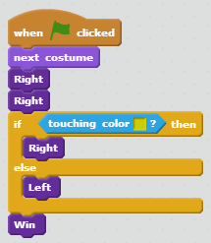
ACTIVITY PART 2
- Using the "next costume" block as well as the other blocks, solve 3.7, 3.8, 3.9, and 3.10.
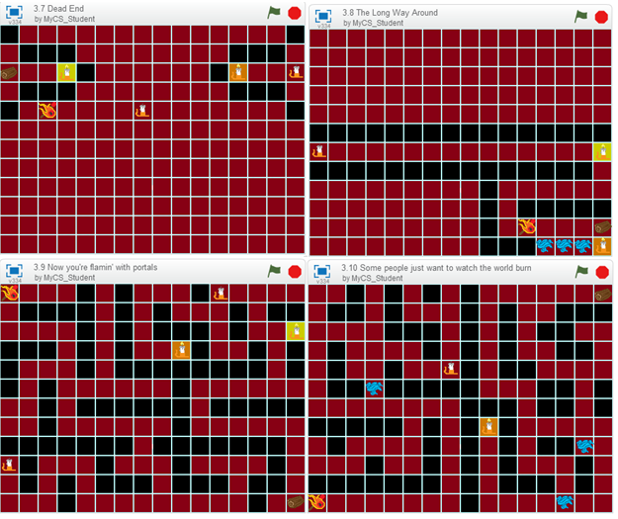
Section B: Part 1: Day 4 Lesson Plan
REFLECTION PART 2
- Conditionals define interactions between humans and computers. By changing the costume of the sprite, the condition changed which allowed the sprite to pass through the portal.
- Sensing is an important part of conditionals. Sensing supplies the input for the "if" part of the conditional.

Build Your Own Maze, Part Two
DESCRIPTION
This unit allows you to create your own maze in Scratch using a template. This new template includes a villain and portals.
LINKS
old https://docs.google.com/document/d/1mrBtZpj58f0ukQwzaVpP3E1PLBD6DgmFFfSflDZmDrk/edit?usp=sharing
Building Mazes in Scratch II Lesson Plan
Scratch World 00: Part 1 Day 5 Template
MOTIVATION AND CONTEXT
- After working through all of the puzzles in Worlds 01, 02, and 03, you should have a grasp of the basic concepts of sensing and interactions, as well as motion and puzzle creation.
- In this section you will apply these concepts to make your own unique maze game by choosing the locations of the sprites as well as the direction the villain is facing.
Section B: Part 1: Day 5 Lesson Plan
ACTIVITY SETUP
- Have everyone get to World 00: Part 1 Day 5 Template.
- Your screen should look like this. If it does, you're ready to make your own puzzle.

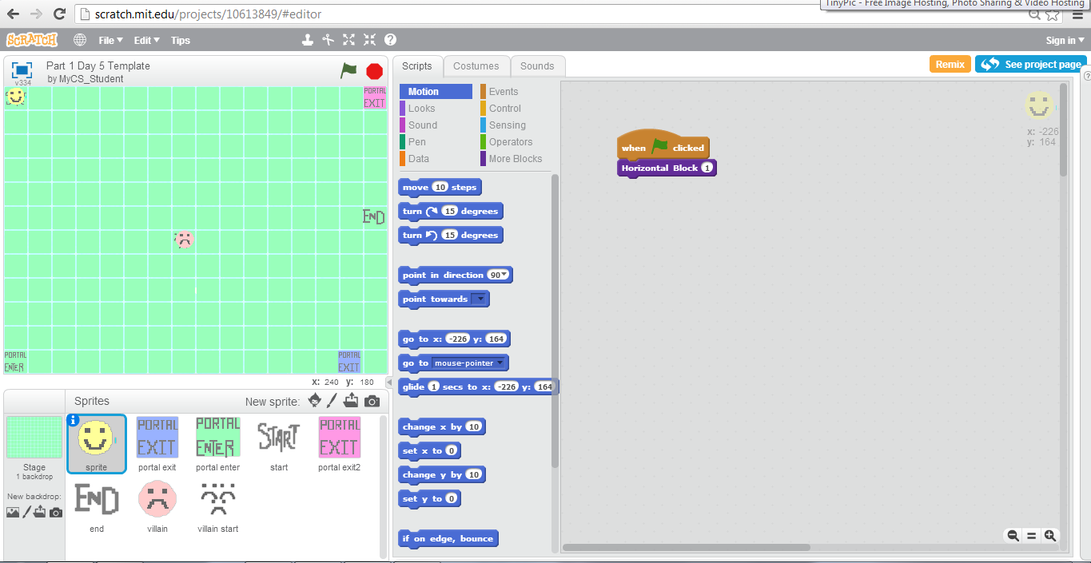

Section B: Part 1: Day 5 Lesson Plan
ACTIVITY PART 1
- To change the direction that the villain travels in, click on the "villain" sprite. In its "More Blocks" section, there are blocks for each of the four classic directions.

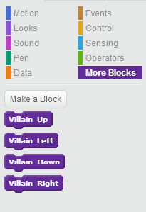

- The villain will travel in this direction until it hits a wall and then it will go back to the villain start.
- Experiment with villain location and motion, feel free to use the information that you learned in "Build Your Own Maze Part 1" to make a maze.
Section B: Part 1: Day 5 Lesson Plan
REFLECTION PART 1
- Adding the villains makes the maze more interesting. Yet, adding the portals from World 03 can make it even more complex.
- Click and drag the portal entrances and exits to create a new puzzle. If you paint new sprites for the portal exits be sure to color the squares under them so that anyone who plays your maze will be able to use "touching color" to teleport from one place to another.
ACTIVITY PART 2
- Create your own maze by moving the sprites to new locations and choosing a villain direction.
- Feel free to make new backgrounds and costumes for your maze.
Section B: Part 1: Day 5 Lesson Plan
REFLECTION PART 2
- By adding portals and villains you can make a more challenging puzzle that you can save on Scratch and share with others.
GAME CREATION
- Adding villains and portals are important pieces to add to any game. Many video games have some sort of enemy which you have to interact with. By choosing the direction the villain moves you control it, creating the challenge for the user.
- Portals are often used in games because they represent interaction between the computer and the user, advancing the game.

