MOTIVATION
Humans and computers use and understand very different versions of data. We encode and decode data in order to switch between these different versions. We also encode data in order to prevent other people from learning information we want to keep private.

OBJECTIVES
Students will:
- Learn methods to encode and decode messages by identifying patterns
- Gain intuition for how to find patterns in sequences
- Learn the importance of encoding and decoding data

RESOURCES FOR THIS SECTION
Presentation: Encoding and Decoding Data ( Source / PDF )
Day 1 Lesson Plan: Encoding and Decoding Data ( Source / PDF )
Day 1 Worksheet: Encoding and Decoding Messages (Source / PDF)
Day 1 Worksheet Solutions ( Source / PDF )
Day 2 Lesson Plan: Encoding and Decoding Data ( Source / PDF )
Day 2 Worksheet: Make Your Own Code ( Source / PDF )
Day 2 Optional Activity: More Cryptography! ( external link )

Encoding and Decoding Data: Day 1
Welcome to Day 1 of Encoding and Decoding Data!

OBJECTIVES
Today the students will learn methods to encode and decode letters and numbers. They will also gain intuition for finding patterns in sequences.

SAMPLE AGENDA
- Watch Agent Zhivago video and discuss when and why encoding is necessary
- Activity: Encoding and Decoding
  - Watch the Intro video
  - Have students complete the encoding and decoding messages activity ( Source / PDF) in pairs or small groups
  - Go over solutions ( Source / PDF ) and discuss the activity
  - Watch the Reflection video
- Bonus: Watch "Imperfections in Encoding" video, do the mini activity, and talk about the discussion questions.

MOTIVATING CONTEXT
People have used methods of encoding and decoding information for a long time, often during times of war and political intrigue! For example, Julius Caesar used the Caesar Cipher to encode all of his private correspondence, so enemies couldn't spy on him. The Freemasons used the Pigpen Cipher to keep their membership and secret rites private. (We'll learn these ciphers in the activity!)
Codes are not only used by people, but also by computers. Encoding and decoding are important tools for computers, which use them to interpret information efficiently. Sounds, images, videos, letters, colors and more can be encoded and decoded by computers.

VIDEO: MEET AGENT ZHIVAGO

THINKING ABOUT ENCODING
In the video above Agent Zhivago received a secret message from his comrade.
In what other circumstances might it be necessary to send or recieve a secret, encoded message?
Why does a computer scientist need to understand how encoding and decoding work?

ACTIVITY SETUP: ENCODING AND DECODING
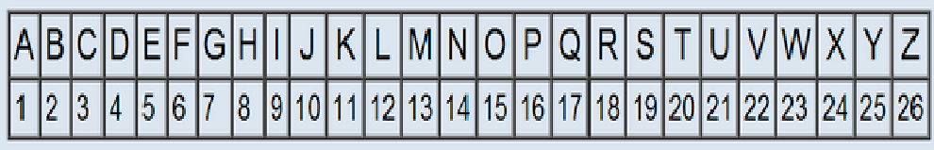
First, we will introduce encoding by showing a simple method of encoding in which every letter corresponds to a number: A=1, B=2, C=3, D=4 ...
Using this encoding, the word AND would be encoded to 1-14-4 .
Encoding information means only people who know the pattern can decode and understand the information. This can be helpful when you have information that you want to share with a specific person and keep secret from everyone else.

YOUR TURN
Before moving on to the activity, try out this example problem to make sure you understand how encoding and decoding works.
- Using the code above, encode the phrase "message"
- Using the code above, decode 8-9-7-8 6-9-22-5 25-15-21-18 14-5-9-7-8-2-15-18
- Now figure out the new set of rules and decode the phrase 7-19-18-8 18-8 9-22-5-22-9-8-22-23
Once you have tried all the example problems look at the answer key to check your answers.

ACTIVITY
Open the Encoding and Decoding Messages worksheet and begin decoding the messages. Click on the link or the image below to get started.
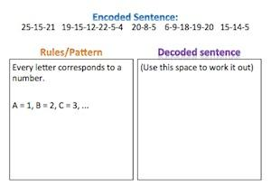

ACTIVITY WRAP-UP DISCUSSION
Decoding messages can be a difficult task.
Which aspects of encoding and decoding were the most difficult for you?
Which aspects were the easiest?
When might the process of encoding and decoding fail or become very difficult? The following video featuring Carly Rae Jepsen may help you answer this last question. Hint: Think about language translation as a form of decoding.

VIDEO: IMPERFECTIONS IN ENCODING

YOUR TURN
As you saw in the "Imperfections in Encoding" video, computers do not always translate phrases correctly. Now, you will get to see this first hand!
Type the phrase "How long does it take for a computer to translate ten pages?" into Google Translate. Translate the English phrase into German, translate the German into Arabic, translate the Arabic into Japanese and then translate the Japenese into Finnish. Finally, translate the Finnish back into English. What did you get?
Can you figure out where the translation went wrong?
What are some of the problems Google Translate has to deal with when encoding and decoding languages?
Do you think some languages are harder to encode and decode than others?

VIDEO: ACTIVITY REFLECTION

VIDEO: DAY 1 WRAP-UP

WRAP UP DISCUSSION
Today we have learned different methods of encoding and decoding and built up our intuition for finding these patterns. In fact, encoded messages are all around us.
Can you think of more examples of encoded information in your everyday life that have not already been mentioned?

VIDEO: ENCODING, DECODING, AND ITS RELATIONSHIP TO CRYPTOLOGY

Encoding and Decoding Data: Day 2
Welcome to the second day of Encoding and Decoding! The students will finish up the activities that weren't finished during the first day. This lesson also includes additional information about language encoding, which was introduced in Day 1.

OBJECTIVES
Today the student will continue gaining intuition for finding patterns in given sequences and learning methods to encode and decode letters and numbers. They will also discuss how language translation can be a form of encoding and decoding and how this differs from other types of codes.

SAMPLE AGENDA
- Watch the "Word Lens" video and discuss how translating between different languages is an example of encoding and decoding.
- Activity: Methods of Coding
- Activity: Make Your Own Code ( Source / PDF )
- Debrief the "Make Your Own Code" activity
- Watch wrap-up video, "Decoding in WWII"

MOTIVATIONAL CONTEXT: LANGUAGES
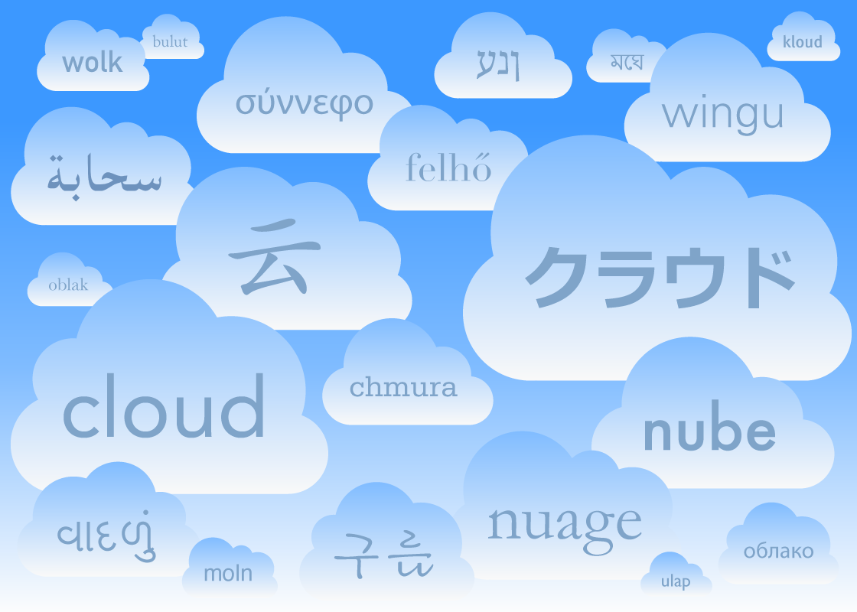
Today, there are approximately 6800 distinct human languages in the world. Language is one of the main barriers for communication between people from different parts of the world. Translation allows the exchange of ideas between two cultures to be conducted more easily. Translation is an example of encoding and decoding of data so that it may be interpreted.

VIDEO: WORD LENS
Fill browser
THINKING ABOUT "WORLD LENS"
Do you think it is difficult to build a set of rules to translate between different languages? Why or why not?
What are some of the problems you might run into when translating?

INTRODUCTORY ACTIVITY
First, decode the statement 3-15-4-5 using the pattern shown above where 1 = A, 2 = B, 3 = C...
Now, decode the following italian phrase "codice". Feel free to use google translate to help you!

What is different about these two encodings? What is the same?
How might one type of encoding be more difficult than another to decode?
Which type of encodings do you think are easiest for a computer to decode? Which are the hardest?

ACTIVITY: METHODS OF CODING
Here is an example of an encoded message and the correct decoded answer. Figure out what the method of decoding is.
[METHOD]
ARBE ---> ____________________ ---> BEAR
Now that you know the decoding method, try to decode these encoded messages.
[ENCODED] [DECODED]
OASTERSROLLERC ____________________
TOPLAP ____________________

ACTIVITY DEBRIEF
How is the decoding method used above similar to a letter by letter code such as A = 1, B = 2, C = 3,...? How is it different?
How is the decoding method used above similar to a language translation? How is it different?

ACTIVITY: CREATING CODES
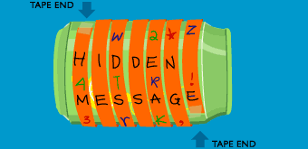
Now it's your turn! Open the Encoding and Decoding worksheet and create your own encoded statement. Then, give your encoded message to a partner to see if they can figure out what method you used to encode your message. After your partner figures out the rules you used, they should try to decode your message. Either click on the link above or the image below to get started.
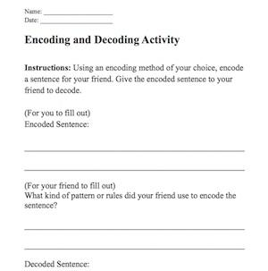

REFLECTION
Was your code decoded?
Were you able to decode your partner's message?
Was your code more similar to a letter by letter encoding or a language translation? What about your partner's code?
What makes a code easy or difficult to solve?
Are all codes solvable?

MORE DECODING
If you have extra time and want more decoding, give these cryptograms a try! Just click on the link or the picture below to start decoding!
