MOTIVATION
Binary is the language computers use when they carry out tasks. When you ask a computer to solve a problem, the computer must convert your problem into binary before the problem can be solved. Therefore, understanding binary is an important part of understanding how computers think.

OBJECTIVES
Students will:
- Learn how to count in binary.
- Learn how to convert between binary and base ten numbers.
- Practice decoding using binary.

RESOURCES
Lesson Plan (3 days): ( Source / PDF )
Day 1: Binary Numbers Activity ( PDF )
Day 1: Binary Cards for the Activity ( PDF )
Day 1: Binary Lesson ( PDF )
Day 1: Worksheet 1 (Binary Numbers) ( PDF )
Day 1: Worksheet 2 (Working with Binary) ( PDF )
Day 2: Worksheet 3 (Sending Secret Messages) ( PDF )
Day 2: Worksheet 4 (Email and Modems) ( PDF )
Day 3: Worksheet 5 (Counting Higher than 31) ( PDF )
Day 3: Worksheet 6 (More on Binary Numbers) ( PDF )

Data Representation with Binary: Day 1

OBJECTIVES
In this lesson we will introduce the binary number system and how to count in binary. Students will learn how to convert between binary and decimal numbers.

BEFORE CLASS
- Print out the binary cards (available here) to give to the students
- Watch this video explaining the CS Unplugged Binary Dots Activity ( PDF )

SAMPLE AGENDA
- Watch the Fun Introduction video with Agent Zhivago
- Explain the context: what makes a number "binary"? Why are binary numbers important?
- Watch Introductory Video or explain how binary works
- Watch the Binary Card Counting Video
- Complete the CS Unplugged Binary Dots Activity ( PDF )
- Have students complete worksheet 1 (Binary Numbers) ( PDF ) and worksheet 2 (Working with Binary) ( PDF )
- Go over the worksheets
- Watch the conclusion video
- Complete the reflection
- Watch the wrap up video

VIDEO: FUN INTRODUCTION

CONTEXT
In everyday life, we typically represent numbers in base 10. The ones place (the digit farthest to the right in the number) represents the number of 1s in our number. The tens place represents the number of 10s in our number. The hundreds place represents the number of 100s, and so on. For example, the number represented by "123" is made of one 100, two 10s, and three 1s: 100 + 2x10 + 3x1 = 123.
Binary is a different system of counting and is the way computers take in, process, and store information. It's also referred to as base 2, since we need a new place for every multiple of 2 instead of each multiple of 10. In order to understand how computers work, and to make them work better for us in the future, it's useful to learn the binary number system.

VIDEO: INTRODUCTORY ACTIVITY

VIDEO: BINARY CARD COUNTING

ACTIVITY SETUP
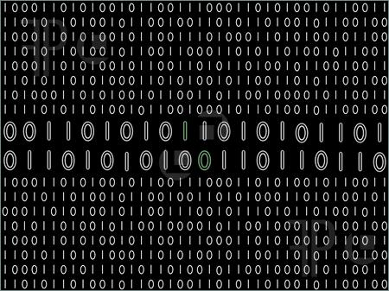
Pick five students to hold the cards representing binary numbers. Have them stand at the front of the classroom so the rest of the class can see the binary numbers. Make sure the cards are in descending numerical order (greatest to least when read from left to right). Using the cards, go over the concepts in the CS Unplugged Binary Dots Activity to give the students a visual understanding of how binary works, and prepare them to do this on their own for the worksheets.

BINARY ON YOUR OWN
Now that we have covered how to use the binary cards to make numbers, go through Worksheet 1 (Binary Numbers) with your students to make sure they're on the right track. Click on the link or the picture below to get started.
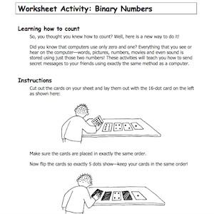

DECODING BINARY
Try to decode each of the encoded numbers on Worksheet 2 (Binary Numbers) using what we have learned so far about binary numbers. You can use the small cutout cards for help. Click on the link or the picture below to get started.
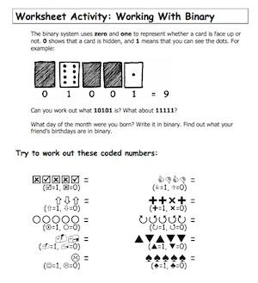

VIDEO: CARD COUNTING REFLECTION

VIDEO: DAY 1 WRAP-UP

REFLECTION
What did you learn today? What are the differences between the base 10 and the base 2 systems? Why do computers use binary instead of base 10?
Can you convert the binary numbers in the "Binary Birthdays" video below to base 10?
For more practice, try out this Scratch game.

VIDEO: WRAP-UP: BINARY BIRTHDAYS

Data Representation with Binary: Day 2

OBJECTIVES
In this lesson the students will become more familiar with binary. They will practice decoding binary into decimal numbers, letters, and words.

SAMPLE AGENDA
- Watch Decimal to Binary Gameshow video
- Have students complete Worksheet 3 (Sending Secret Messages) ( PDF )
- Explain Boop-Beep activity and have students complete Worksheet 4 (Email and Modems) ( PDF )
- Watch the wrap up video

VIDEO: BINARY TO DECIMAL GAME SHOW
NOW YOU TRY!
Let's try a few examples of converting binary to decimal.
Convert 1101 to decimal.
Convert 10001 to decimal.
Bonus question: What is 101010 in decimal?

ACTIVITY: CHRISTMAS TREE MESSAGE
Now we've reviewed how to convert binary to decimal numbers. Put this new skill to work by decoding the message in the Christmas tree lights in Worksheet 3 (Sending secret Messages). If a light is on, it represents a 1 and if a light is off, it represents a 0. This is just like what happens in a computer! Each series of five digits corresponds to a different letter. What is Tom trying to say? Click on the link or the image below to get started!
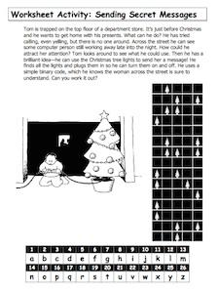

VIDEO: BOOP-BEEP ACTIVITY INTRO

ACTIVITY: BOOP-BEEP
For this activity, the sound "boop" represents a zero and the sound "beep" represents a 1. Using the same relationship between binary numbers and letters as in the Christmas Lights exercise, try to decode the message in Worksheet 4 (Email and Modems)! Then try sending a message to a friend! Click on the link or the picture below to start.
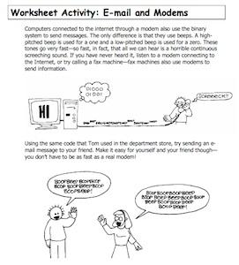

VIDEO: ACTIVITY REFLECTION

REFLECTION
Today we learned how to convert a binary number into a decimal number. We also learned some ways that we can use binary to encode and decode messages.
Can you think of other ways to use binary to communicate a message?

Data Representation and Binary: Day 3
Welcome to Data Representation and Binary, Day 3!

OBJECTIVES
In this lesson students will become even more comfortable with binary numbers. They'll explore more difficult binary concepts, such as what happens if a zero is added to the end of a binary number.

SAMPLE AGENDA
- Show Marble Adding Machine Video
- Complete Worksheet 5 (Counting Higher than 31) ( PDF )
- Complete Worksheet 6 (More on Binary Numbers) ( PDF )
- Watch the wrap up video
- Reflect on what you learned today

VIDEO: MOTIVATION VIDEO: MARBLE ADDING MACHINE

MOTIVATION: MARBLE ADDING MACHINE

In this video, we are adding numbers together and representing their sum in binary. This gives us a way to visualize what is happening when we add in binary. Try to answer these questions:
What happens if you add a marble (which represents a 1) to an empty slot (which represents a 0)?
What happens when you add a marble (1) to a slot that already has a marble (1)? Where do each of the marbles go?

MISS FLEXI-TOES
Let's test our skills by going through Worksheet 5 (Counting Higher than 31). Click on the link or the picture below to get started. It might be useful to use the binary cards (available here).
What is the biggest number Miss Flexi-Toes can count up to using only her ten fingers and ten toes?
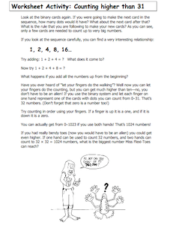

ADDING ZEROES
What happens if a zero is added to the end of a binary number? Try it out on Worksheet 6 (More on Binary Numbers).
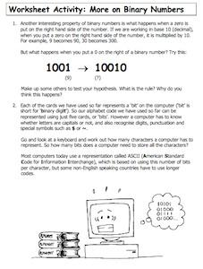

REFLECTION
What did you learn today?
Why do you think binary is important (or not important)?
If there is extra time, or for more practice in the future, students can try the Cisco binary game or the Scratch binary game and see how high of a score they can get!

