OBJECTIVES / SUMMARY
We will continue to work with sound in Scratch and learn about loops in the context of music. By the end of this unit, you will be able to work comfortably with the note, rest, and repeat blocks and utilize the repeat block to make your code more concise.

LINKS
Lesson Plan
Presentation Slides
Student Notes
Worksheet

NOTES AND REPEATS
Now we'll introduce you to three different blocks that will be useful for creating sound in Scratch!

Play Note
The play note block plays a musical note. It has 2 variables that you can change:
- The note.
- How long the note plays (in beats).

Rests
The rest block makes the script pause. It has one variable:
- How long the pause lasts (in beats).

Repeat
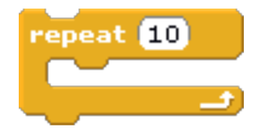
The repeat block tells the computer to do the same thing over and over again. It has one variable:
- How many times to repeat the blocks inside the repeat block.
Other blocks can be played inside of the repeat block. Those blocks inside will be repeated as many times as you want.
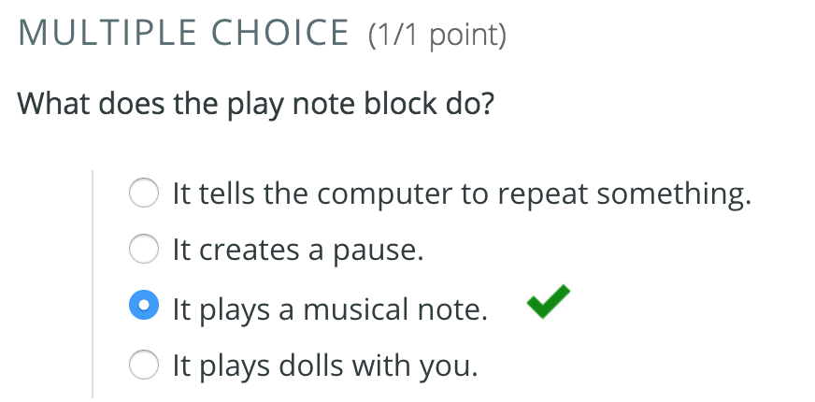
Now that we're familiar with these three blocks, you can complete this worksheet.
Once you're done, try creating a song in Scratch using the play note, rest, and repeat blocks.

WRAP-UP / REGROUP / REFLECT
What did you learn today?
Notes and pauses are at the core of making songs. Repeat blocks make it easier for us to write the code for those songs.

