MOTIVATION
Computer science is about creating tools to solve problems. This unit introduces the idea of algorithms as sets of instructions that can be used to solve problems.

OBJECTIVES
Students will be able to:
- Create strategies for solving problems.
- Define the word algorithm.
- Create algorithms to solve certain kinds of logic puzzles.

RESOURCES
Lesson Plan (Source / PDF)
Activity: Mazes (Source / PDF)
Activity: Solving Puzzles (Source / PDF)
Activity Solutions: Solving Puzzles (Source / PDF)

SOLVING PUZZLES
Whether it's games or working with data, computer science is about creating tools to solve problems. We want our tools to work for not just one specific problem, but a whole category of problems. In order to make a tool like this, we have to make a step-by-step procedure called an algorithm.

OBJECTIVES
This lesson presents computer science as problem solving with computers. Students will learn that an algorithm is just a list of instructions for solving a type of problem, and will create some algorithms to solve puzzles.

SAMPLE AGENDA
- Context and Intro to Problem Solving
- Activity: Problem Solving and Mazes (Source/PDF/Solutions)
- Discussion: Introduction to Algorithms
- Video: What is an Algorithm?
- Activity: Solving Puzzles (Source/PDF)
- Activity: Towers of Hanoi (Link/Printout)
- (Optional) Class Activity: GeoGuessr (Link)
- Activity Debrief

CONTEXT: WHERE ARE WE?
We've discussed the definition of a computer and explored some hardware and software parts. We've seen how computer science can create tools to change the way people live and work. We've talked about encoding and decoding messages, and we've learned a little about the programming language Scratch.
We'll keep on focusing on software, and take a look at how we create instructions to solve problems. Solving problems is a huge part of computer science: we start with a problem, task, puzzle, or question, and a set of guidelines. These guidelines might tell us about ways we can solve the problem, or ways we can't solve the problem. When we solve the problem, we end with an answer or a solution.
We can think about the problem-solving process as a journey from point A to point B. There could be more than one way to get there, some ways can be better than others depending on what we define "better" as. We could need tools to help us along the way. In many ways, problem solving is a journey.

PROBLEM SOLVING AND MAZES
In this activity, we'll look at problem solving as finding a way to get from A to B, or start to finish. The mazes below all have different guidelines or rules about the ways we can solve the maze. Click on the image below for the PDF version of the handout:
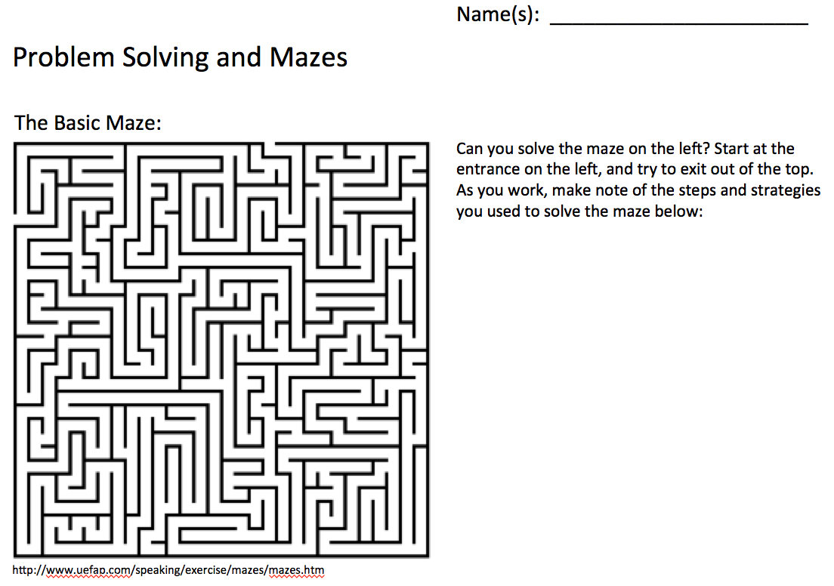
Solutions to the mazes and possible algorithms are available here.

MAZE ACTIVITY DEBRIEF
Which maze was your favorite? Least favorite?
What maze did you make? What were the rules?
How did you solve each maze? What process did you use to solve the mazes?
Did the rules affect how you tried to solve the maze? How did the type of maze affect your problem-solving process?
Were there any common themes in you thought process about the different puzzles?

INTRODUCTION TO ALGORITHMS
When you solve a maze, you might go through a process for figuring out the solution. Where is the start? Where is the finish? What paths can you take out of each end? Do they connect? You could probably make a list of steps and strategies you could use to solve the problem.
We also know that the type of problem affects the process you use. You probably didn't solve the basic maze and the tilt maze the same way! But the list of steps and strategies you used to solve one tilt maze could probably be used to solve another tilt maze, even if the tilt mazes had different solutions.
This is where the idea of an algorithm comes in. An algorithm is a set of step-by-step instructions to solve a type of problem. For example, the first steps in a maze algorithm would probably be to figure out where the start is, where the finish is, and what the rules are. A good algorithm for a problem should be a precise and detailed set of small steps that anyone would be able to use to solve any problem in the same category. Think about the instructions you made in the PB & J activity in the first unit: you had to tell your instructor to twist the lid of the peanut butter jar counterclockwise to open it.
You might remember the word "algorithm" from when we talked about Google's search algorithm, or the "Code Stars" video where a computer scientist said that computer science is about writing algorithms to break down hard problems into smaller steps. Algorithms appear often in computer science, because they are an essential component of problem solving. The video below gives a simple example of an algorithm we use to count!

VIDEO: WHAT IS AN ALGORITHM?

DEBRIEF: WHAT IS AN ALGORITHM?
What's an algorithm?
Have you ever used an algorithm to solve a problem or complete a task?
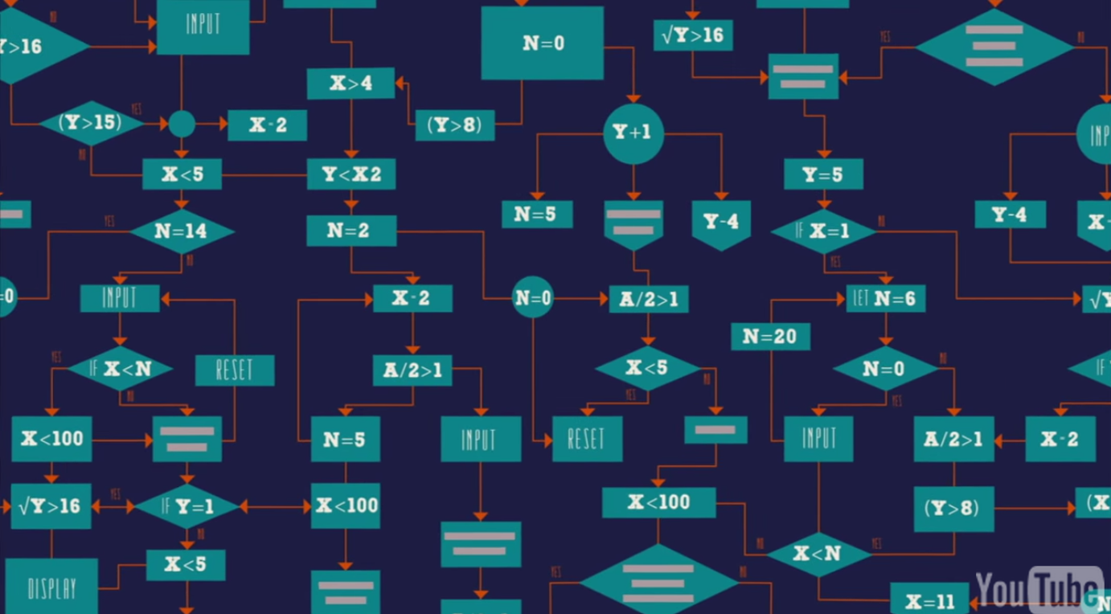
You've probably followed lots of step-by-step instructions before. You probably know how to tie your shoes -- there's an algorithm for that! You might have made cookies before -- there's an algorithm for that, too! Recipes are very much like algorithms.
Any time you follow step-by-step instructions to complete a task or solve a problem, you're using an algorithm.

ACTIVITY: SOLVING PUZZLES
In this activity, we'll start by solving individual puzzles and then create a set of instructions that someone can use to solve a whole type of puzzle. The image below links to the worksheet for the activity.
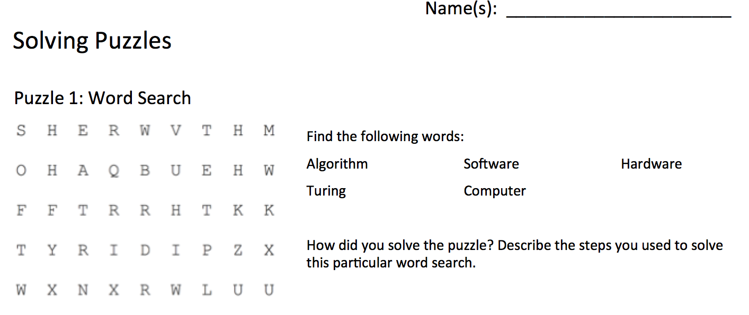

TOWERS OF HANOI
Towers of Hanoi is a puzzle game consisting of rings on three pegs. The goal is to move all the rings from the leftmost to the rightmost peg, with two constraints. You can only move the topmost ring from any peg, and you can not put a ring on top of a smaller one. You can try it out below in Scratch. Use the numbers on your keypad to lift then place a ring. Alternatively, you can use any stackable objects of different sizes, or print out a set.
Can you come up with an algorithm to solve the puzzle for any number of rings?
Hint: If you are trying to move a stack of rings to a target peg , you can move all but the biggest ring to the other peg, then move the last ring to the target peg, and then move the rest on top of it. (You can re-use this hint to move the smaller stacks as well)
There are a lot of ways to describe a towers of Hanoi solving algorithm, here's one that works for any even tower height:
- Move a ring from A to B, or B to A.
- Move a ring from A to C, or C to A.
- Move a ring from B to C, or C to B.
- If it's not solved, go back to step 1.
This is an algorithm because it is a step-by-step process for solving a type of problem. Try it for yourself! To solve odd numbered towers, just switch steps 1 and 2.

OPTIONAL GROUP ACTIVITY: GEOGUESSR
GeoGuessr is a web-based geographic discovery game that utilizes random Google Street View locations and requires players to guess their location in the world using only the clues visible in Street View. Click on the image below to access the site in a new tab.
This fun game can be integrated as a in-class group activity.
Students may be asked to describe the algorithm he/she uses to find the location as an excercise to demonstate how algorithms are utilized in problem solving.

ACTIVITY DEBRIEF
Let's review: what is an algorithm?
You just made algorithms to solve four (five, including the optional activity) puzzles:
- Finding all the words in a word search
- Sudoku
- Solving the Towers of Hanoi
- (Optional) GeoGuessr
The idea is that anyone can now take any word search, number maze, or group of people, and use your set of instructions to complete the task.
What problem-solving techniques did you use for each puzzle?
Which puzzle was the most difficult to solve? What techniques did you use for that puzzle?
How did you create an algorithm for each puzzle? What were the steps you took?
Which algorithm was the hardest to write? Why?
Bonus: could you write an algorithm for coming up with algorithms?

