MOTIVATION
With the invention of the internet came a massive influx of data and information. Now that we have such an abundance of information, the problem of searching arises. How do we find what we are looking for when there is so much information out there? In this unit we explore searching algorithms and how these algorithms help us find what we are looking for.

OBJECTIVES
Students will understand:
- how searching is used every day
- what the linear searching algorithm is and when to use it
- what the binary searching algorithm is and when to use it
- the key differences between linear and binary searching

RESOURCES
Day 1: Linear Searching
Lesson Plan ( Source / PDF )
Activity ( Source / PDF )
Day 2: Binary Searching
Lesson Plan ( Source / PDF )
Activity ( Source / PDF )

Linear Searching

OBJECTIVES
- Students will learn how companies such as google use searching algorithms
- Students will discuss how they use searching in their everyday lives
- Students will learn what the linear searching algorithm is and when to use it

SAMPLE AGENDA
- Watch "The Google Search Engine" video and have students discuss how they use search on a day to day basis
- Have students pair up and complete the Linear Searching Activity ( Source / PDF )
- Debrief the activity using the "Activity Discussion" questions
- Formally introduce the linear search algorithm and watch the "Linear Searching" video
- Watch the "Siri vs. Google Voice Search" video

MOTIVATION: GOOGLE SEARCHING
In the world today there is a nearly endless supply of information, or data, available. However, all this information does not help us very much if we cannot search through all of it and find exactly what we want. In this section we will talk about some search algorithms that we often use to find things in our everyday lives. However, searching isn't just an important skill to have when we need to find our favorite red shirt or where the yogurt is located in the super market. It is also extremely important to be able to search efficiently on the internet. Companies such as Google have made our lives easier by creating search engines. These search engines use very complex searching algorithms to find information. Even though the searching algorithms we use in our day to day lives are much less complex than the search algorithms Google uses, the same purpose underlies both types of searches. We want to be able to find exactly what we are looking for in the shortest amount of time possible. Watch the video below to see how Google constantly improves its famous search algorithm!

VIDEO: THE GOOGLE SEARCH ENGINE

VIDEO DISCUSSION
As you can see, Google puts a lot of time and effort into improving its search algorithm. In fact, developing efficient searching techniques is an important part of computer science.
However, the internet is not the only place where it is necessary to search through a lot of data to find what you want. Can you think of other senarios in which it is important to be able to efficiently search for something?

INTRODUCTION TO SEARCHING
Often times in computer science it can be beneficial to find the maximum, the minimum, or any specific value in a list. In this activity you will try to figure out the most efficient method of searching for a specific element in an unordered list of elements.

ACTIVITY: INTRO TO LINEAR SEARCHING
Split into pairs and pick one person to be the chef and one person to be the artist. The artist cuts up the color cards and the chef cuts up the food cards. The artist should mix up the color cards and arrange them in a line face down. The chef should try to find the "red" card, but he/she can only flip over one card at a time. After the chef finds the card, he/she should shuffle the food cards and place them face down on the table. Now, the artist should try to find the "pizza" card keeping in mind that he/she can only flip over one card at a time. Click on the link above or the picture below to get started! Good luck!
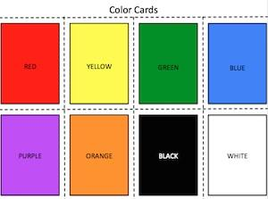

ACTIVITY DISCUSSION
How many cards did you have to flip over before finding the card you were looking for?
How many cards did your partner have to flip over before finding the card he/she was looking for?
What method did you use in order to find your card quickly?
How many cards would you have had to flip over if you were asked to find a card that was not included in the set of color or food cards?
If you had 100 cards what is the maximum number of cards you would have to overturn using your method?
If you had x number of cards what is the maximum number of cards you would have to overturn using your method?

LINEAR SEARCHING
One common method that you could have used in the activity above is the linear search algorithm. This algorithm is often applied when you have a list of unordered elements (these elements can be numbers, colors, foods, or anything else you can think of) and want to find a specific element in this list. Linear searching finds the target element by looking at the first element in the list and comparing it to the element it wants to find (the target element). If the first element is the target element the linear search is done! Otherwise, the next element in the list is compared to the target element. This process continues until the target element is found or the list of elements ends.
What the video below to see for yourself how linear searching works.

VIDEO: LINEAR SEARCHING

LINEAR SEARCHING WRAP UP
What made finding the card difficult or frustrating?
How might you arrange the cards differently to help you find your card faster? Hint: Could you find the card faster in a list that was arranged from lowest to highest?
If you don't know the answer to the last question do not worry! We will cover this in more detail in the next section.

SEARCHING IN TECHNOLOGY
As you learned in "The Google Search Engine" video, companies such as google and bing put a tremendous amount of effort into improving their search engines. In the video below you can see how the search algorithms of Siri and Google's voice search compare to each other.

VIDEO: SIRI VS GOOGLE VOICE SEARCH

Binary Searching

OBJECTIVES
- Students will understand what the binary search algorithm is and how to use it
- Students will undertand the difference between linear and binary searching
- Students will understand when it makes sense to use binary searching instead of linear searching

SAMPLE AGENDA
- Talk about how the linear search algorithm is very ineffeicient at searching through sorted lists. Watch the "Searching a Dictionary" video to enforce this point
- Have students pair up and complete the Binary Searching Activity ( Source / PDF )
- Debrief the activity as a class
- Formally introduce the binary search algorithm
- Watch the "Binary Search" and "Binary Searching Example" videos
- Discuss the pros and cons of linear and binary searching

MOTIVATION: SEARCHING IN SORTED LISTS
Yesterday we found that it is possible to find what we are looking for by checking every item and seeing if that item is the one we are looking for. However, this process can be very slow and tedious and this method of searching is completely unecessary if the items you are searching are sorted into a specific order.
Take a dictionary as an example. When you look up a word in a dictionary do you start at aardvark and check every single word in the dictionary until you get to your word? Or do you use another, faster method of searching for your word?
Watch the video below to get a feel for when linear searching become extremely inefficient.

VIDEO: SEARCH SMARTER!

VIDEO DISCUSSION
As we saw in the video, linear searching is a completely ludicrous method to use when you are dealing with sorted lists, such as a dictionary. But what is the best way to approach sorting in a sorted list?
Do you think the person in the video searched the dictionary efficiently the second time?
What method do you use when searching a dictionary?

ACTIVITY INTRO
This activity is similar to the activity you did in the Linear Searching section, but there are a few key differences you need to be aware of. First, there are more cards. Second, the person cutting up the cards needs to rank the cards from least favorite to most favorite and place the cards in this order on the table. Make sure to write down the order of the cards for your own reference!

ACTIVITY: BINARY SEARCHING
Everyone should pair up and each pair should have a copy of the directions, cards, and worksheet. In your pairs pick one person to be the chef and one person to be the artist. The artist should cut the color cards along the dotted lines and then rank the cards from least favorite to most favorite. The artist should make sure to record the order of the cards on the worksheet but make sure not to show the chef what the order is! The artist should then place the cards on the desk in the order he/she just wrote down. The chef should try to find the "red" card by turning over one card at a time.Every time the chef turns over a card, the artist tells the chef if he/she (the artist) like red more or less than the color of the card the chef just turned over. The chef should continue to turn over cards until he/she finds the red card. The goal is to find the red card as quickly as possible. Now, switch roles with your partner and complete the activity with the food cards. This time the chef should rank the cards and the artist should try to find the "soup" card. Click on the link above or on the picture below to get started!
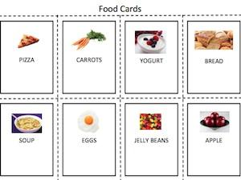

ACTIVITY DISCUSSION
How many cards did you flip over before you found the card you were looking for?
How many cards did your partner have to flip over?
Was this more or less cards than you had to flip over yesterday?
What strategy (AKA algorithm) did you use to find your card? How did this strategy differ from the one you used in yesterday's activity?
If you had 20 cards what is the maximum numbers of cards you would have to turn over using your method? What if you had 100 cards?

BINARY SEARCHING: WHAT IS IT?
One easy and quick way to find an element in a sorted list of elements is to always pick the middle element of the list. So, if you have a list of numbers sorted from least to greatest you would pick the number in the middle of the list and compare it to your target number. If the target number is the middle number you're done! If not, you look to see if the middle number is greater or less than the target number. At this point you can eliminate half the list because you know that half the list is either greater than or less than the target number. Now you just repeat the process and pick the middle number in the remaining list.
To learn more about binary searching watch the video below! Stop the video at 2:25.

VIDEO: BINARY SEARCH

VIDEO INTRO
Now, you know the differenece between linear searching and binary searching. You also know that binary searching works much better than linear searching if you have a sorted list. Watch the video below on searching. Try to find where the student in the video makes a mistake.

VIDEO: BINARY SEARCHING EXAMPLE

VIDEO DISCUSSION
What algorithm did the student in the video use to find the number 85? Hint: did he use linear or binary searching?
Why did the instructor throw some of the cups off the table?
What mistake did the student make at the end of the video? How did this mistake change his searching algorithm?

DISCUSSION: LINEAR SEARCHING VS. BINARY SEARCHING
Not only is it important to know what linear and binary searching are, but you also need to know when to use each algorithm! In general, you want to pick the search algorithm that finds elements fastest.
If you had an unsorted list of numbers what algorithm would you use to find one number in that list?
If you had a sorted list of numbers what algorithm would you use to find one number in that list?
Bonus Question: If you had an unsorted list of 1,000,000 numbers and repeatedly wanted to find numbers in this list which algorithm would you use? Hint: Do you think you should continually use the linear search algorithm or do you think it would be beneficial to sort the list and then use the binary search algorithm?
Do not worry if you can't answer the last question. We will talk more about sorting in the next lesson.

WRAP UP
You have learned what linear and binary searches are. Linear searches can only compare two things (the correct answer and the guess) at once. In a linear search we have to check every comparison possible.
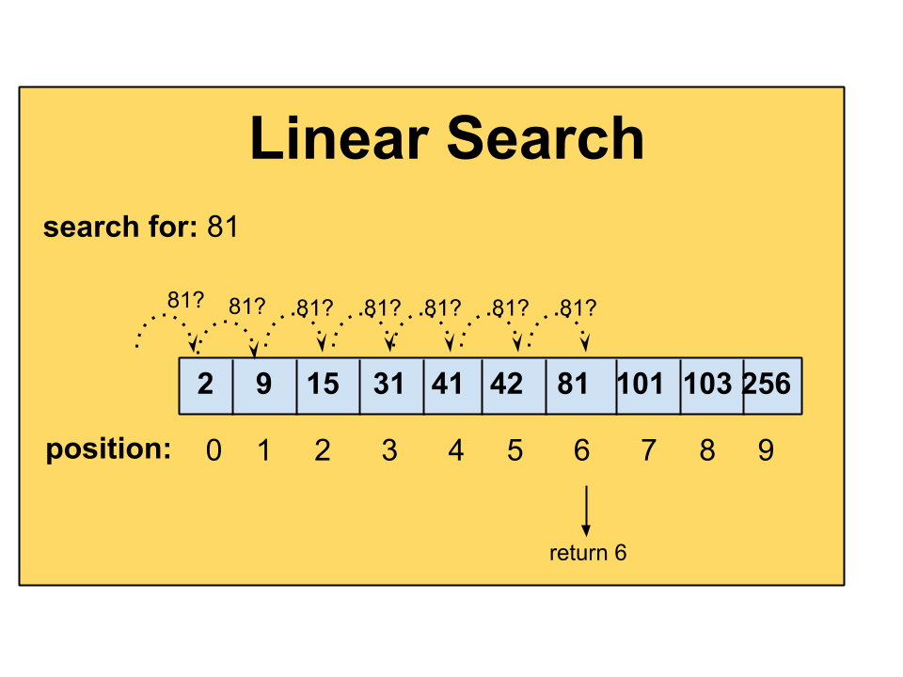
Binary search helps us do fewer comparisons by telling us if the word is "too low" or "too high" and then finally "you got it!" But binary searches have more restrictions. In order to perform a binary search the list must be sorted.
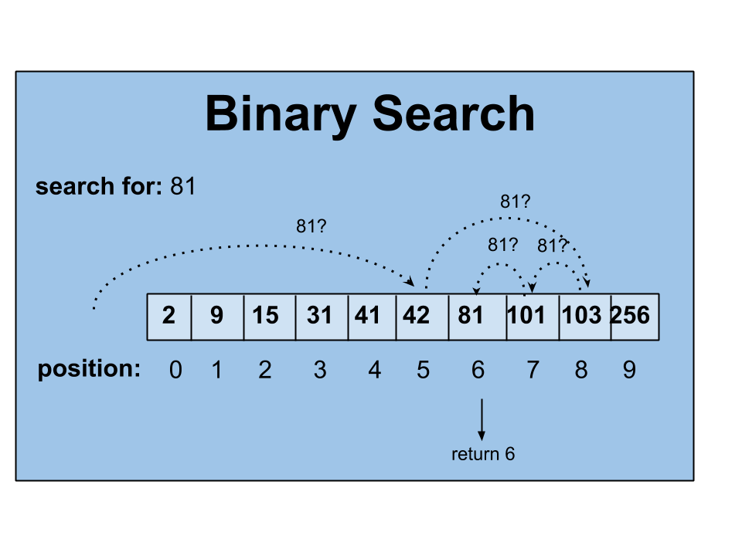
The binary search algorithm is valuable because of its ability to search through huge lists of data relatively quickly. In fact, binary searching is so much faster than linear searching that it is often worth sorting unsorted data just so the binary search algorithm can be applied instead of the linear search algorithm. However, this only applies to data sets that are constantly being searched, not data sets that are only searched once.

