Lesson Plan: Building Mazes in Scratch II
Topic Description: Students learn how to change the locations of the sprites, as well as the direction the villain travels, and make new backdrops that incorporate portals.

Objectives:
The student will be able to:
- Change the position of the sprites.
- Choose the direction that the villain travels.
- Make mazes and backdrops that have portals.

Outline of the Lesson:
- Demo Sprite Repositioning (5 minutes)
- Independent Sprite Repositioning (15 minutes)
- Demo Introduce Villain Direction (5 minutes)
- Independent Work in Scratch (30 minutes)
- Journal Entry (10 minutes)

Teaching/Learning Strategies:

Demo to introduce repositioning sprites (5 minutes)
- Open “Part 1, Day 5 Template” from “World 0- Template” from MyCS_Student. Click “see inside” then press “Remix”.
- Show the students that by clicking and dragging the sprites on the grid you can move them to a new position.
- Show also that when “Reset” is clicked (in the More Blocks section of the Scripts for Sprite) that sprite goes to start, and villain goes to villain start.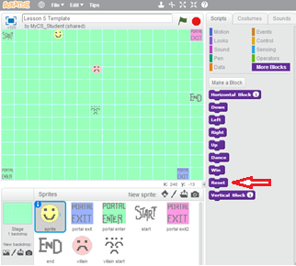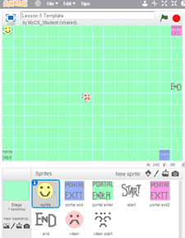
Before Reset After Reset

Independent sprite repositioning (15 minutes)
- Have the students move “sprite”, “start”, “end”, “portal enter”, “portal exit1”, “portal exit2”, “villain” and “villain start”.
- (To edit a different sprite, click on their icon under the grid)

Demo to introduce villain direction (5 minutes)
- From here click on the villain sprite under the grid.
- Click on the More Blocks section to see the blocks “Villain Up”, “Villain Down”, “Villain Left”, “Villain Right”
- Add one of these blocks to the “when flag is clicked block” to have the villain move in that direction.
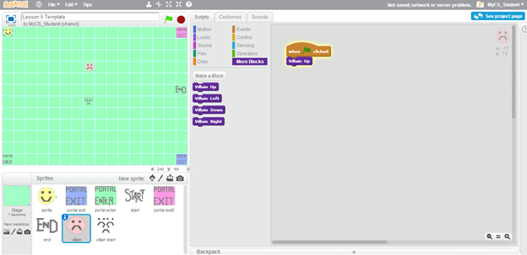

Independent work in Scratch (30 minutes)
- Have students move the sprites, including portals, to different locations than in the Template.
- Have students have the villain move in some direction.
- Challenge students to create their own sprites and backdrops to incorporate in their mazes.
Journal Blog Entry
- Students will answer the question, “what did you learn today”?
Resources:
- http://scratch.mit.edu

