Lesson Plan: Scratch: Enter the Villain
Topic Description: Students will understand movement in Scratch and the repeat block by dodging monsters. This unit continues working through the concepts of Computer Science. It particularly focuses on the "Wait" block in relation to other moving pieces on the Puzzle.

Objectives:
The student will be able to:
- More intuitively understand movement
- Reinforce their understanding of the Repeat block

Outline of the Lesson:
- Demo Level 2.1 (10 minutes)
- Independent Work in Scratch (10 minutes)
- Student Demos (5 minutes)
- Independent Work in Scratch (10 minutes)
- Journal Entry (10 minutes)

Teaching/Learning Strategies:

Demo Level 2.1
- Open up level 2.1 and demonstrate how to position blocks to get the solution
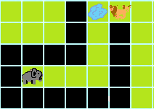
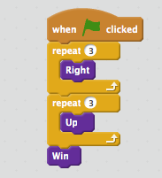
- Click the flag to show what a successful run looks like

- Have the students build the solution successfully
- Explain that they will get bitten if they touch the lion, but it is OK to touch the cubs.

Independent Work in Scratch
- Let the students work through more of the World 2 Puzzles

Student Demos
- Ask for a student who used Repeat blocks in their solution to demonstrate it to the class
- Ask for a student with a cool solution to demonstrate it to the class

Independent Work in Scratch
- Have the students continue World 2 puzzles
- For students who finish, have them try and think of “cool” solutions (for example, one in which they almost touch the lions)

Journal Blog Entry
- Students will answer the question, “what did you learn today”?
Resources:
- http://scratch.mit.edu

