Instructional Day: Day 1 from Unit B, Part 1

Topic Description: Students learn how to use directional blocks to move a sprite.

Objectives:

The student will be able to:

- Build basic programs in Scratch.
- Navigate through mazes using Scratch.

Outline of the Lesson:

- How to access Scratch (10 minutes)
  - Have the students go to www.scratch.mit.edu
  - Have them click on “Join Scratch” in the upper-right corner
  - Other than a username and password, they will need an email address:
    - Have them use mycsstudent@gmail.com
  - Once they are logged in, have them search for MyCS_Student in the search bar at the top of the page
  - The first result of the search will have MyCS_Student highlighted in blue as the username. Have the students to click the link
  - On the next page, have them scroll down until they get to a bar that says “Studios I Curate” and have them click the words that say “view all”
  - Once there, tell them to click on World 1-Ocean, then 1.1 One Direction, and finally the “See Inside” button
  - They should end up at a screen looking like this:
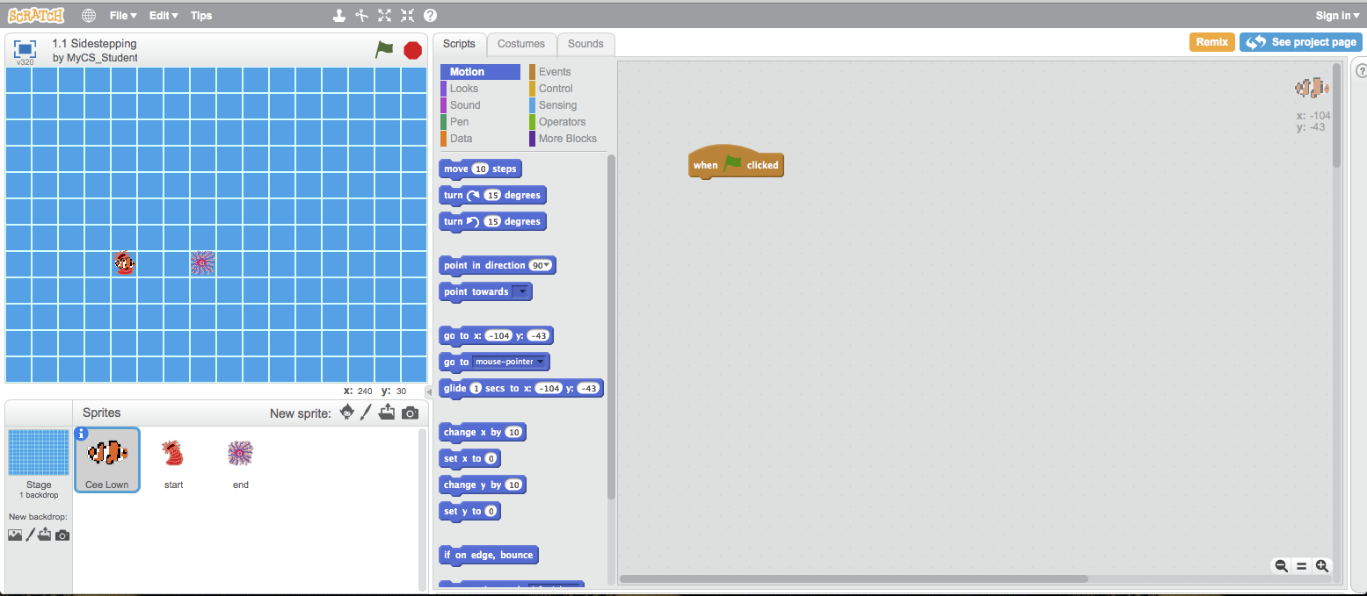

Themes:
- Basic Programs
- Repeat blocks

- Demo Level 1.1 (5 minutes)
  - Open up level 1 and demonstrate how to position blocks to get the solution
  - Click the flag to show what a successful run looks like
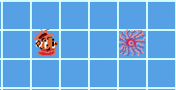
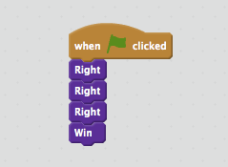

  - Have the students build the solution successfully

- Independent work in Scratch (15 minutes)
  - Let the students work through more of the World 1 Puzzles

- Break (5 Minutes)
  - Using Level 1.9, demonstrate how to use a Repeat block to shorten the code:
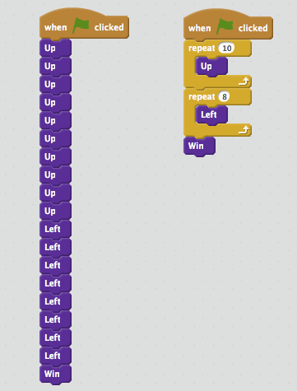

- Independent work in Scratch (10 minutes)
  - Have the students continue World 1 puzzles
  - Encourage those that have finished to go back and use Repeat blocks to solve previous puzzles

- (Optional) Students write a journal/blog entry about what they learned (10 minutes)

