Instructional Day: Day 2 from Unit B, Part 1

Topic Description: Students learn how to make their own costumes for the sprites and their own mazes and backdrops.

Objectives:

The student will be able to:

- Comfortably create new costumes for start, end, and sprite.
- Make mazes and backdrops in Scratch using the paint tool.

Outline of the Lesson:

- Demo to introduce costume creation (5 minutes)
  - Open “Part 1, Day 2 Template” from “World 0- Template” from MyCS_Student. Click “see inside” then press “Remix”.
  - In the remix click on the tab that says “Costumes”.
  - From here draw on the sprite using the tools on the left as a demonstration on how to modify a given sprite.
  - Note that the sprites cannot have black on them (this will be explained later)
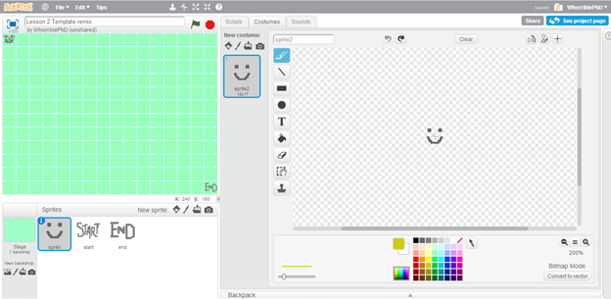
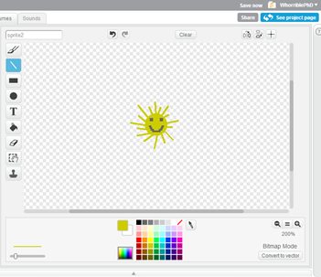

- Independent Sprite Creation (10 minutes)
  - Have the students make their own costume for “sprite”, “start”, and “end”.
  - (To edit a different sprite, click on their icon under the grid)

- Demo of building a maze (5 minutes)
  - Build the maze below in front of the class, using the paint fill tool, as a demonstration of how to create new mazes and backdrops:
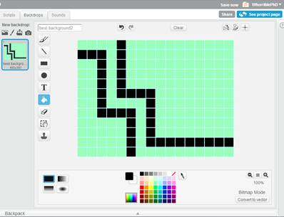
  - Note that the backdrop can be any color, but the walls have to be black. When the sprite touches black it ‘dies’ which is why the sprites can’t have black on them.

- Independent work in Scratch (30 minutes)
  - Have students create their own costumes for “sprite”, “start”, and “end”.
  - Have students create their own maze and backdrop.
  - Challenge students to create a backdrop with two colors apart from the black of the walls.

- (Optional) Students write a journal/blog entry about what they learned (10 minutes)

