Instructional Day: Day 3 from Unit B, Part 1

Topic Description: Students have fun dodging monsters

Objectives:

The student will be able to:

- More intuitively understand movement
- Reinforce their understanding of the Repeat block

Themes:
- Repeat blocks
- Having Fun!

- Demo Level 2.1 (5 minutes)
  - Open up level 2.1 and demonstrate how to position blocks to get the solution
  - Click the flag to show what a successful run looks like
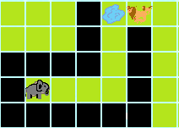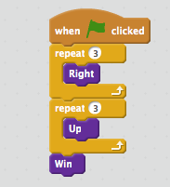

  - Have the students build the solution successfully
  - Explain that they will get bitten if they touch the lion, but it is OK to touch the cubs.

- Independent work in Scratch (15 minutes)
  - Let the students work through more of the World 2 Puzzles

- (Optional) Break (10 Minutes)
  - Ask for a student who used Repeat blocks in their solution to demonstrate it to the class
  - Ask for a student with a cool solution to demonstrate it to the class

- Independent work in Scratch (10 minutes)
  - Have the students continue World 2 puzzles
  - For students who finish, have them try and think of “cool” solutions (for example, one in which they almost touch the lions)

- (Optional) Students write a journal/blog entry about what they learned (10 minutes)

