Instructional Day: Day 4 from Unit B, Part 1

Topic Description: Students learn how to use Sensing and Conditionals to solve puzzles

Objectives:

The student will be able to:

- Understand how to use Scratch to sense the world around them
- Use If Statements to solve puzzles

Outline of the Lesson:

Themes:
- Sensing
- Conditionals

- Demo Level 3.1 (5 minutes)
  - Open up level 3.1 and position blocks to get the solution below:
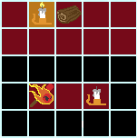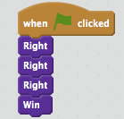

  - Have the students build the solution successfully

- Independent work in Scratch (15 minutes)
  - Let the students work through more of the World 3 Puzzles
  - Tell them that, if they get to 3.5, they should run their solution multiple times to make sure it works each time

- Break (10 Minutes)
  - Using Level 3.5, demonstrate how to use Sensing and a Conditionals to solve the puzzle (either one of the two solutions below is valid):
    - Make sure you show the kids the entire process of building the solution. These are confusing concepts.
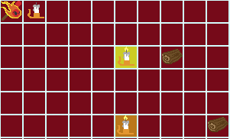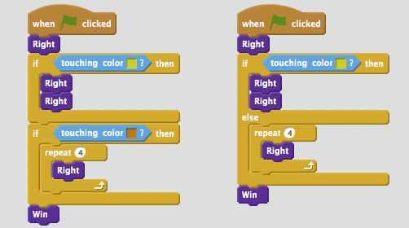

- Independent work in Scratch (15 minutes)
  - Have the students continue World 3 puzzles
  - Some of these (especially 3.6) are challenging, so let the students know they can move on if they get stuck

- (Optional) Students write a journal/blog entry about what they learned (10 minutes)

