Instructional Day: Day 9 from Unit B, Part 2

Topic Description: Students learn how to create a new dance and background music for the game

Objectives:

The student will be able to:

- Make a simple dance for the sprite to do when it wins.
- Make a song for the game to play in the background as the sprite is moving

Outline of the Lesson:

- Demo to introduce dance creation (10 minutes)
  - Open “Part 2 Day 9 Template” from “World 0- Template” from MyCS_Student. Click “see inside” then press “Remix”.
  - It should look like:
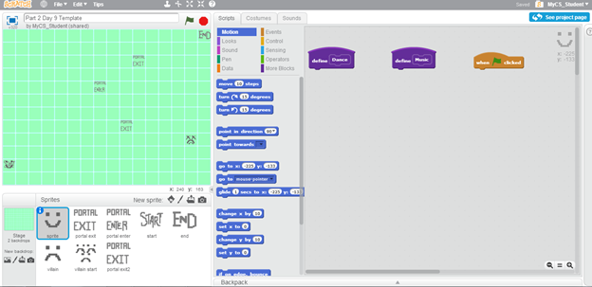
  - Build the following script and then click on the script to watch the sprite move.
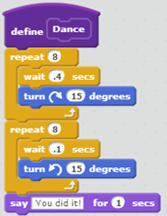
  - Note that there has to be time between turns since the turns them selves are immediate.

- Independent dance creation (15 minutes)
  - Have them create a dance for the sprite which stays inside the grid square, so it only uses “turn ( ) degrees”, “wait ( ) secs”, and “say [ ] for ( ) secs”.
  - Challenge them to try and use some of the other “Looks” blocks in the dance.

- Demo to show how to share puzzles (10 minutes)
  - Show the students that they can make their own music using the “Sound” blocks
  - Make the following script and click on it to hear it play (click again to stop it).
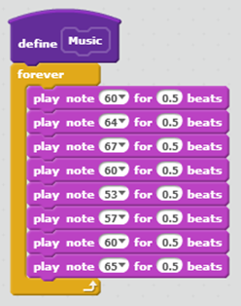
  - Let them know that it should be in a “forever” loop so that it will play the whole time the game is going.

- Independent students creating their own music(15 minutes)
  - Have them make their own song to go in their maze.
  - Challenge them to try use other instruments and tempos in the music.

- (Optional) Students write a journal/blog entry about what they learned (10 minutes)

