Instructional Day: Day 2 from Unit B, Part 2

Topic Description: Students will learn how to tell what Sprite they are touching

Objectives:

The student will be able to:

- Have a fuller understanding of what Sensing is
- Solve more sophisticated puzzles

Outline of the Lesson:

Themes:
- Sensing

- Demo Level 5.1 (5 minutes)
  - Open up level 5.1 and ask the students for the solution:

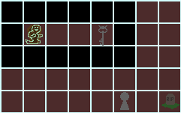

  - This puzzle is a repeat of an older puzzle, so the kids should be able to find the solution quickly, which is some variation of:

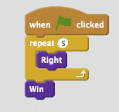
- Independent work in Scratch (15 minutes)
  - Let the students work through more of the World 5 Puzzles

- Break (10 Minutes)
  - Using Level 5.4, demonstrate how to use Sensing to solve the puzzle:
    - Have the students open up the Sensing menu and figure out which block should be used to detect what Sprite they are touching.
    - Then, show them the solution below:

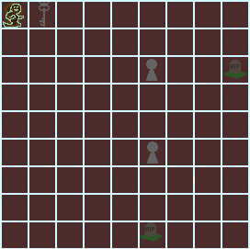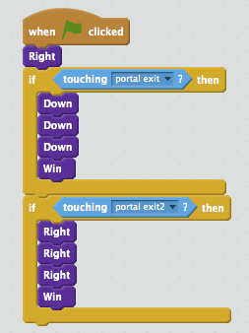

- Independent work in Scratch (15 minutes)
  - Have the students continue World 5 puzzles

- (Optional) Students write a journal/blog entry about what they learned (10 minutes)

