Instructional Day: Day 3 from Unit B, Part 2

Topic Description: Students learn how to use Horizontal Block and Vertical Block.

Objectives:

The student will be able to:

- Solve puzzles by only moving horizontally and vertically.

Outline of the Lesson:

Themes:
- Movement using Horizontal Block and Vertical Block.

- Demo Level 6.1 (10 minutes)
  - Open up level 6.1 and position blocks to get the solution below:

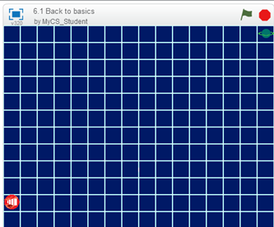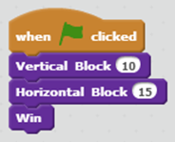

  - Ask the students what numbers would the solution be if they were going from the end to the start? (“Vertical Block (-10)” and “Horizontal Block (-15)”)
  - Use this to explain how any of the puzzles can be solved using Vertical Block ( ) and Horizontal Block ( ) instead of Up, Down, Left, and Right.
    - Vertical Block (Postitive Number) = Up
    - Vertical Block (Negative Number) = Down
    - Horizontal Block (Postitive Number) = Right
    - Horizontal Block (Negative Number) = Left

- Independent work in Scratch (15 minutes)
  - Let the students work through more of the World 6 Puzzles

- Break (10 Minutes)
  - Using Level 6.6, demonstrate how to use Sensing and Conditionals to solve the puzzle:
    - The main point of this level is to show that everything that was done in the earlier levels, is possible to do with “Vertical Block” and “Horizontal Block”

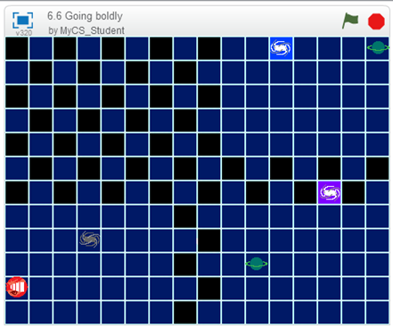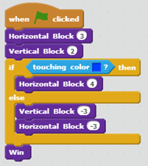

- Independent work in Scratch (15 minutes)
  - Have the students continue World 6 puzzles

- (Optional) Students write a journal/blog entry about what they learned (10 minutes)

