Instructional Day: Day 4 from Unit B, Part 2

Topic Description: Students learn how to change the locations of the portal exits, as well as learn how to save and share their puzzles

Objectives:

The student will be able to:

- Change the position of portal exits.
- Save puzzles to their profiles and share them with the Scratch community

Outline of the Lesson:

- Demo to introduce repositioning portal exits (5 minutes)
  - Open “Part 2 Day 3 Template” from “World 0- Template” from MyCS_Student. Click “see inside” then press “Remix”.
  - It should look like this:
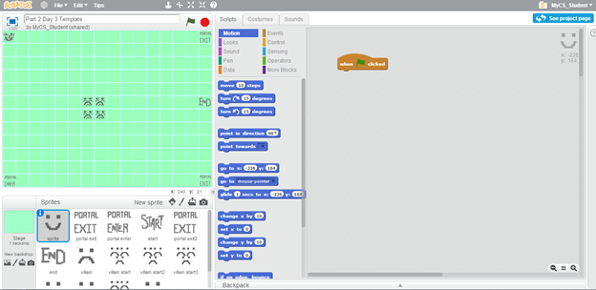
  - Show the students that by clicking and dragging the sprites on the grid you can move them to a new position.
  - Remind them that now they know to use “touching portal exit” so the portal exits don’t have to be different colors.

- Independent maze creation (25 minutes)
  - Have them create mazes with all of the sprites, moving them to different locations.
  - Challenge them to apply the ideas that they have seen in the past creation lessons, such as costume creation and villain direction.

- Demo to show how to share puzzles (5 minutes)
  - Show the students that by clicking the “share” button that they can publish their maze on the profile that they have created.
  - Once they have posted their maze, have them search for another classmate’s username in the search bar at the top of the page
  - The first result of the search will have their name highlighted in blue. Have the students to click the link.
  - This will give them access to the other student’s project.

- Independent students trying other students’ projects (15 minutes)
  - Let the students try each other’s puzzles.
  - Have them try at least 3 puzzles from other classmates and fill out the mini-worksheet for each of the other puzzles that they try.
  - Feel free to collect these worksheets, but try to give them to the people whose puzzles they worked on so that they can learn from what people thought of their maze.

- (Optional) Students write a journal/blog entry about what they learned (10 minutes)

