Instructional Day: Day 6 from Unit B, Part 2

Topic Description: Students learn how to use movement in one direction and rotation to solve puzzles

Objectives:

The student will be able to:

- Solve puzzles by only moving in one direction and turning.

Outline of the Lesson:

Themes:
- Movement using turning and direction.

- Demo Level 8.1 (10 minutes)
  - Open up level 8.1 and position blocks to get the solution below:

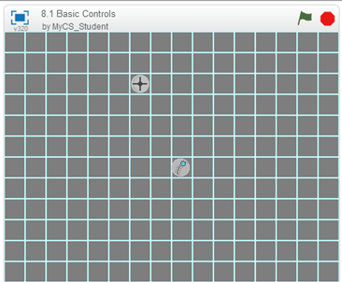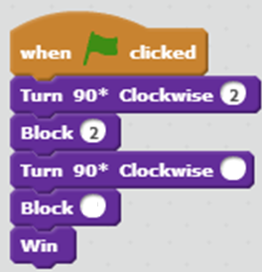

  - Ask the students what numbers should go in the last two blocks. (1 and 4) Note: It starts pointed to the right, which is why it has to turn 180* to go left.
  - Use this to explain how any of the puzzles can be solved using just “Block” and “Turn 90* Clockwise”.

- Independent work in Scratch (15 minutes)
  - Let the students work through more of the World 8 Puzzles

- Break (10 Minutes)
  - Using Level 8.6, demonstrate how to use Sensing and Conditionals to solve the puzzle:
    - Timing is important in this level. Make sure to show this solution a few times so that it goes through both portals.

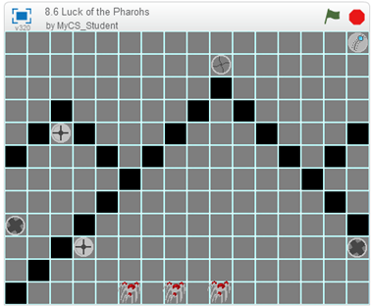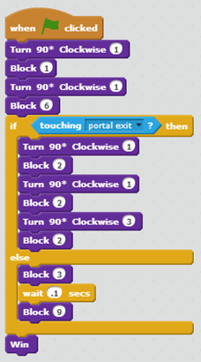

- Independent work in Scratch (15 minutes)
  - Have the students continue World 8 puzzles
  - (Optional) Puzzle 8.10 is especially challenging when it comes to timing, but it is possible to do without any “wait” blocks. If someone finds this solution, have them demonstrate their solution to the class and explain their code.

- (Optional) Students write a journal/blog entry about what they learned (10 minutes)

