(OPTIONAL) Instructional Day: Day 7 from Unit B, Part 2

Topic Description: Students will have fun solving gridless puzzles

Objectives:

The student will be able to:

- Think spatially without using a grid

Outline of the Lesson:

Note: This lesson is optional, as it does not teach any new computer science techniques. However, the levels are quite fun, so I suggest letting the kids have fun with it.

Themes:
- Spatial Awareness

- Independent work in Scratch (20 minutes)
  - Let the students work through the World 9 Puzzles
    - This is a very independent day and is more designed for the students to have fun.

- Break (5 minutes)
  - Go back to World 1 and have the kids solve a few of the puzzles
  - Emphasize just how far they’ve come and how good they are at programming

- Independent work in Scratch (20 minutes)
  - Let the students work through more of the World 9 Puzzles
    - If any finish, let them know that, if they scroll down in the code window, they will find the code for Vertical Block and Horizontal Block. Tell them to mess with some of the numbers and see what happens:

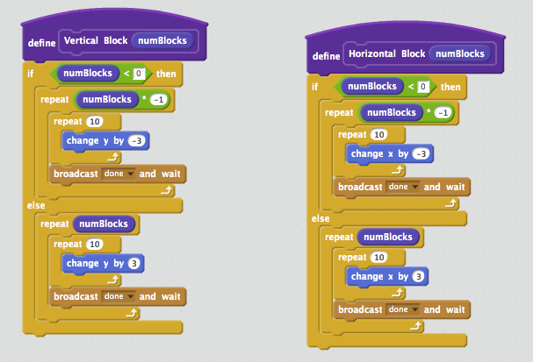

- (Optional) Students write a journal/blog entry about what they learned (10 minutes)

