(OPTIONAL) Instructional Day: Day 8 from Unit B, Part 2

Topic Description: Really challenging (and really fun) puzzles

Objectives:

The student will be able to:

- Solve ridiculous puzzles

Outline of the Lesson:

Note: Like the last lesson, this one is entirely optional. However, these are by far my favorite levels, so I would highly suggest letting the kids try them out.

Themes:
- Having Fun!

- Independent work in Scratch (20 minutes)
  - Let the students work through the World 10 Puzzles
    - If the students can’t see the solution, tell them to head toward the exit and see what happens

- Break (5 minutes)
  - Go to the Harveyashi Muddru level and run this code:
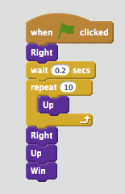

  - Tell them that the exit is programmed to disappear if you get close, so you cannot win with that code there.
  - Don’t tell them, but we are hoping someone will go into the end sprite and modify the code so that you can win.

- Independent work in Scratch (20 minutes)
  - Let the students work through more of the World 10 Puzzles

- (Optional) Students write a journal/blog entry about what they learned (10 minutes)

