Lesson Plan: Beginning Motion in Scratch
Topic Description: Students learn how to use directional blocks to move a sprite.

Objectives:
The student will be able to:
- Build basic programs in Scratch.
- Navigate through mazes using Scratch.

Outline of the Lesson:
- How to access Scratch (10 minutes)
- Demo Level 1.1 (5 minutes)
- Independent Work in Scratch (15 minutes)
- Repeat Demonstration (5 minutes)
- Independent Work in Scratch (10 minutes)
- Journal Entry (10 minutes)

Teaching/Learning Strategies:

How to access Scratch
- Have the students go to www.scratch.mit.edu
- Have them click on “Join Scratch” in the upper-right corner
- Other than a username and password, they will need an email address:
  - Have them use mycsstudent@gmail.com
- Once they are logged in, have them search for MyCS_Student in the search bar at the top of the page
- The first result of the search will have MyCS_Student highlighted in blue as the username. Have the students to click the link
- On the next page, have them scroll down until they get to a bar that says “Studios I Curate” and have them click the words that say “view all”
- Once there, tell them to click on World 1-Ocean, then 1.1 One Direction, and finally the “See Inside” button
- They should end up at a screen looking like this:
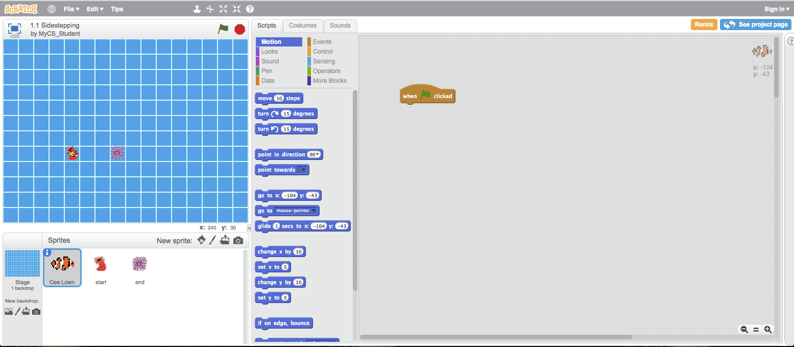

Demo Level 1.1
- Open up level 1 and demonstrate how to position blocks to get the solution
- Click the flag to show what a successful run looks like
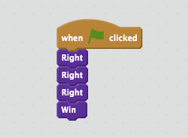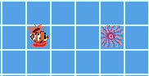
- Have students build the solution successfully by clicking on the green flag

Independent Work in Scratch
- Let students work through more of the World 1 puzzles

Demonstrate how Repeat Works
- Using Level 1.9, demonstrate how to use a Repeat block to shorten the code:
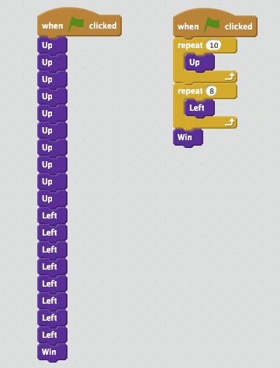

Independent Work in Scratch
- Have the students continue World 1 puzzles
- Encourage those that have finished to go back and use Repeat blocks to solve previous puzzles

Journal Blog Entry
- Students will answer the question, “what did you learn today”?
Resources:
- http://scratch.mit.edu

