Instructional Day: Day 5 from Unit B, Part 2

Topic Description: Students will learn how to use more Control statements

Objectives:

The student will be able to:

- Use repeat until and wait until to solve puzzles
- Solve more sophisticated puzzles

Outline of the Lesson:

Themes:
- Control statements

- (Optional) Demo Level 7.1 (5 minutes
  - The students should be able to solve 7.1 easily.
  - Ask students to solve the puzzle, which should boost their confidence

- Demo Level 7.2 (5 minutes)
  - For this puzzle, the frog first walks to the right to the portal entrance. Then, until he is touching portal exit (the exit near the flower), the frog walks one step to the right. This means he walks from the other portal exit into a portal entrance. When the frog gets to the correct exit, he walks to the flower.

  - Walk the students through solving this problem
    - Make sure they understand, as some of the puzzles are impossible without using a Repeat Until

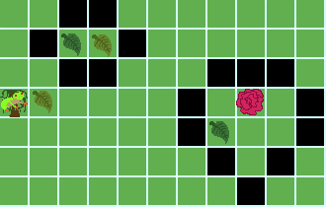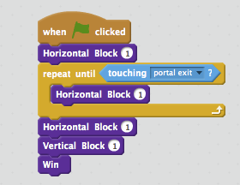

- Independent work in Scratch (15 minutes)
  - Let the students work through more of the World 7 Puzzles

- (Optional) Break (10 Minutes)
  - At this point, a few kids should have solved 7.3
  - Go back to World 4 and level 4.10
  - Using Repeat Until, show how short the solution to this Challenge Level is

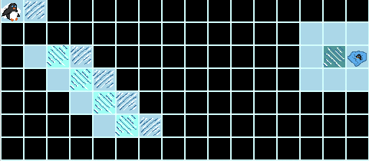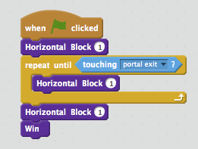

- Independent work in Scratch (15 minutes)
  - Have the students continue World 7 puzzles

- (Optional) Students write a journal/blog entry about what they learned (10 minutes)

