Lesson Plan: Sensing and Conditionals
Topic Description: This unit focuses on the use of sensing and conditional statements to traverse through portals in each level. Sensing is when a sprite knows when it is touching a certain color. Conditional statements are "if-then" statements, allowing for something to happen only if a certain criteria is met.

Objectives:
The student will be able to:
- Understand how to use Scratch to sense the world around them
- Use If Statements to solve puzzles

Outline of the Lesson:
- Demo Level 3.1 (5 minutes)
- Independent Work in Scratch (15 minutes)
- Demo Sensing and Conditionals (5 minutes)
- Independent Work in Scratch (15 minutes)
- Journal Entry (10 minutes)

Teaching/Learning Strategies:

Demo Level 3.1
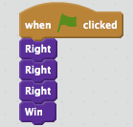
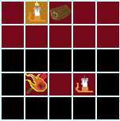
- Open up level 3.1 and position blocks to get the solution below:
- Have the students build the solution successfully

Independent Work in Scratch
- Let the students work through more of the World 3 Puzzles
- Tell them that, if they get to 3.5, they should run their solution multiple times to make sure it works each time

Demo of Sensing and Conditionals
- Using Level 3.5, demonstrate how to use Sensing and a Conditionals to solve the puzzle (either one of the two solutions below is valid):

- Make sure you show the kids the entire process of building the solution. These are confusing concepts.
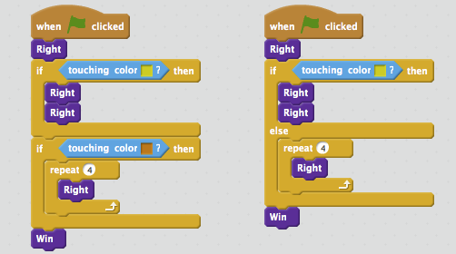
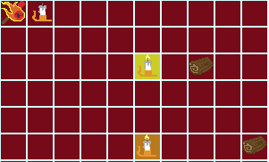

Independent Work in Scratch
- Have the students continue World 3 puzzles
- Some of these (especially 3.6) are challenging, so let the students know they can move on if they get stuck

Journal Blog Entry
- Students will answer the question, “what did you learn today”?
Resources:
- http://scratch.mit.edu

