Instructional Day: Day 1 from Unit D, Part 2

Topic Description: Students learn how to use keyboard control and detect edges.

Objectives:

The student will be able to:

- Comfortably use blocks that are started by a key press.
- Make the computer react to a sprite being on the edge of the screen.

Outline of the Lesson:

- Motivation (2 min)
  - Explain: Games are interactive - they require some user input and then a reaction from the computer.
- Demos (8 min)
  - We start with a reaction the computer makes to some state of being.
    - 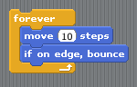
  - To add a more interesting reaction, we need to do some math. Build this block out of the previous one.
    - Emphasize:
      - Why not use the x-coordinate 240 to check if the sprite is close to the edge?
      - Why use the function abs? What does it do?
    - 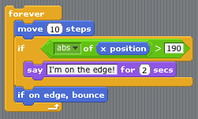
  - Now we add some human interaction. The sprite can now move up/down/right/left. Build these blocks in addition to the last one.
    - 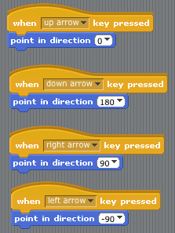
- Making Changes (10 min)
  - The sprite can move in 4 directions, but only says it is on the edge if it is on the left or right edge. How could the script be changed to have the sprite say it is on the edge when it is near the bottom or top edge? Have students make suggestions/guide them along as you change this script. It may help to have them make the changes on their own computers as you make changes somewhere everyone can see.
    - A possible (but by no means the only) solution:
    - 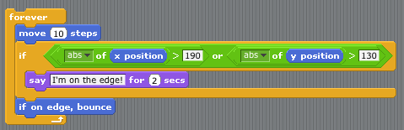
- Independent Work (25 min)
  - Allow students to take what they have learned and explore.
- (Optional) Blog (10 min)
- Students should write about their experiences and ideas in their blog.

