Instructional Day: Day 4 from Unit D, Part 2

Topic Description: Students learn to use the timer, and explore scoring methods

Objectives:

The student will be able to:

- Use the timer
- Use multiple variables to calculate a final score

Outline of the Lesson:

- Motivation (2 min)
  - Explain: Games often have a win condition. When that happens, we can look back at things that have happened and judge the player on their abilities.
- Demos (8 min)
  - We start by changing the appearance of the stage as in previous lessons. Click on the stage in the bottom right corner. Then, click on its backgrounds tab. Choose “Edit” or “Paint” to change/create a new background. Make the stage look similar to the picture below (account for any color blind students?):
  - Now we will make the sprite react to the background. Make sure you have clicked on the sprite in the bottom right corner and then on its scripts. When you put in the touching color blocks, remember to click on the colored square and then on the colors in the stage to set them to the right colors. Create the script below as well as check the checkbox next to the “timer” in the Sensing tab.
    - 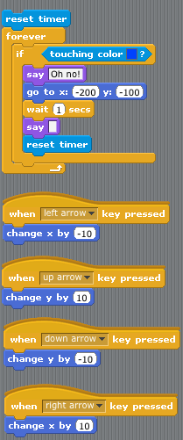
    - Show what happens. Every time the blue is touched, the sprite is sent back to the beginning and the timer is reset.
- Making Changes (10 min)
  - Change the code along with the students so that touching the red zone gives a victory cheer. Here is a possible solution:
    - 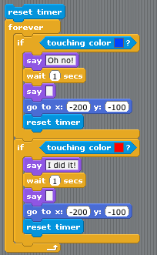
  - Change the code so that some kind of score is announced at the end. In this possible solution, we count the amount of time the sprite is touching blue and add that to the time it took to get there:
    - 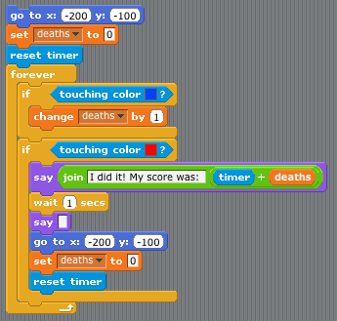
- Independent Work (25 min)
  - Encourage students to create their own mazes with their own scoring systems.
- (Optional) Blog (10 min)
  - Students should write about their experiences and ideas in their blog.

