Instructional Day: Day 1 from Unit D, Part 3

Topic Description: Students learn how to use the Pick Random block in Scratch.

Objectives:

The students will be able to:

- Utilize the random number generator within their Scratch scripts.

Outline of the Lesson:

- Introduce the Pick Random block (5 minutes)
  - Show the students where to find the Pick Random block.
  - Explain that the block chooses a different random number in the given range every time the block is run in the script.

- Demonstration of Pick Random block (5 minutes)
  - Build the following script in front of the class to show how to use the Pick Random block:

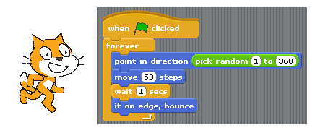

- Demonstrate the use of the Pick Random block in a game (10 minutes)
  - Build the following script in front of the class to inspire students to use randomness in their Scratch games:

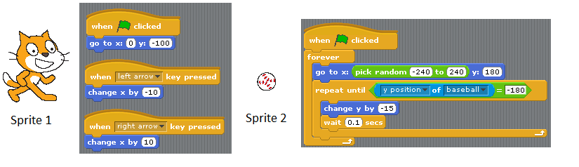
  - You can add additional ball sprites with identical scripts to make the game more challenging:

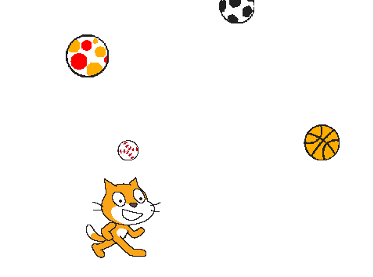

- Independent work in Scratch (20 minutes)
  - Have students create a game in Scratch that utilizes random number generation

- (Optional) Students write a journal/blog entry about what they learned (10 minutes)

