Instructional Day: Day 4 from Unit D, Part 2

Topic Description: Students learn how to simulate gravity using Scratch.

Objectives:

The student will be able to:

- Create an environment with gravity for their sprites.

Outline of the Lesson:

- Motivation (2 min)
  - Explain: Including gravity in a game environment makes the game more realistic and could be utilized as a challenge.
  - We start with a simple sprite that can move up and down, depending on whether the up and down arrows are hit.
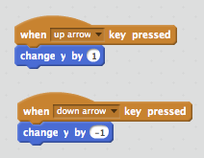
  - To make it more interesting, we’d like the sprite to be affected by gravity. This means that if no keys are pressed, the sprite will move down at a constant speed. Build this block off the previous one.
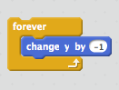
  - Now we can add some human interaction. Build upon the previous block such that the sprite can move up. Emphasize the use of an “if-else” loop.
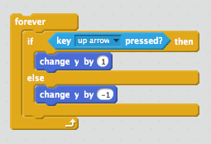
- Making Changes (10 min)
  - Right now, the cat can only move up and down. How could we edit our block of code so that the cat can also move to the right and to the left? One example is:
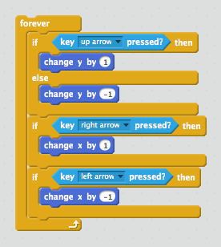
  - Want more of a challenge? Edit the block so that the cat bounces off of the top edge if it hits it.
- Independent Work (25 min)
  - Allow students to take what they have learned and explore.
- (Optional) Blog (10 min)
- Students should write about their experiences and ideas in their blog.

