Instructional Day: Day 1 from Unit D, Part 1

Topic Description: Students learn how to use Say and Wait in Scratch to make sprites interact with one another.

Objectives:

The student will be able to:

- Comfortably create new sprites and choose costumes for them.
- Use Say and Wait to create conversations between their sprites.

Outline of the Lesson:

- Demo to introduce the Say and Wait blocks (5 minutes)
  - Build the following short script to show how to use the Scratch interface and introduce the first two blocks:
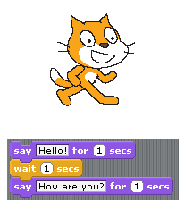
- Demo of interactions using Say and Wait with knock-knock joke (10 minutes)
  - Build the two sprites and scripts below in front of the class as a demonstration of how to create new sprites and use the Say and Wait blocks:

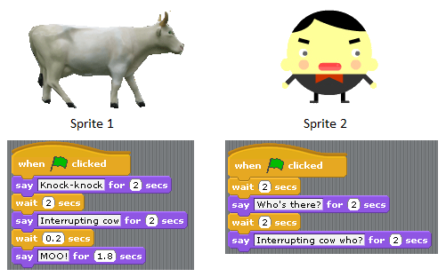

- Independent work in Scratch (30 minutes)
  - Have students create their own Say and Wait play
  - Students should use more than one sprite with different costumes
  - Challenge students to create a Say and Wait play using more than two sprites

- (Optional) Students write a journal/blog entry about what they learned (10 minutes)

