Notes: Setting and Changing Tempo & Volume Name:___________________________________

Always know the tempo!

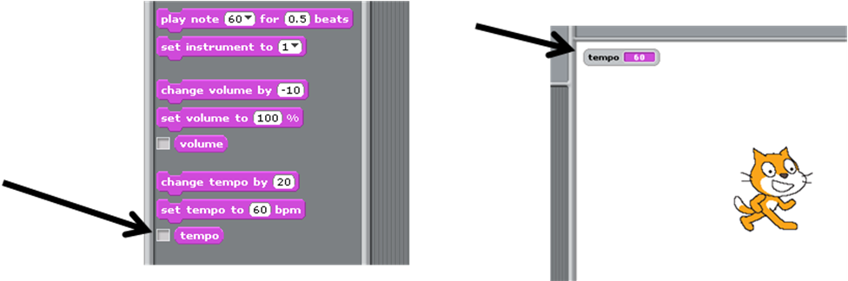

If you check the checkbox next to the “tempo” block, the _________________________________ will be displayed on the _________________________.

Review: Set Tempo

The set tempo block sets the speed at which notes play. It has 1 variable:
- You can change how many beats play per minute.

When using the set tempo block, it _________________________________________ what the current tempo is. Set tempo will set the tempo to the number you _______________________.

Change Tempo

The change tempo block _______________________ or _______________________ the tempo by whatever amount you want. It has 1 variable:
- You can change how much to increase or decrease the tempo. You may use ______________________ or ____________________ numbers.

When using the change tempo block, it ____________________________ what the current tempo is. Set tempo will ___________ or _____________________ from the current tempo.

Example: Which gives you a faster tempo?

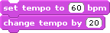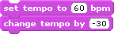

1. First, the tempo is set to _______. 1. First the tempo is set to ______.
2. Then, the tempo is increased by ________. 2. Then, the tempo is decreased by _____.
3. The final tempo is ________ beats per minute. 3. The final tempo is _______.

Volume works the same way!

- Use the __________________ next to the “volume” block to always see the volume.

- Use the ____________________ block to reset the volume to the level you want.

- Use the ___________________________ block to increase or decrease the volume by a certain amount.

