Moon Tanks

Created and designed by Jacob Seene, Chris Weisiger, and Krislin Lee

"You can't hit me, I'm the gingerbread man!" - Anonymous

System Requirements

Windows 2000/XP, OpenGL, glut

History

On 30 January 2053, an epic battle began for the only satellite of the planet Earth, the moon. In the pitch-blackness of the dark side of the moon, an alien colony was discovered, a colony preparing for war. And thus the nations of the world rallied to the cry of blood, and landed large amounts of military forces on the dark side of the moon. After fighting the alien colony for nigh on a decade, on the 17th of November 2062, the alien colony was defeated. However, upon surveying the wreckage from the colony, a new technology was obtained: an efficient method for creating an oxygen rich atmosphere from water.

Now, nearly 20 years later, the moon has a completely inhabitable surface with an atmosphere similar to the Earth's. But a new war has begun. Due to the colossal expense of removing the heavy mechanical units from the moon, many were abandoned and left to rust on the moon's surface. But now the moon has a use for them once again, for the nations of the Earth have begun battling for control on the moon's surface.

Your mission is to commandeer one of these abandoned units, specifically one of the tanks, which have long since lost their gas to evaporation, and eliminate any other tanks within your tank's firing range. Beware, however, as there are likely other nations with commandeers such as yourself. Have no mercy in killing them alongside their worthless contraptions.

General Information

Moon Tanks is a 3-D turn-based game in which 2-8 players control stationary tanks and fire bullets at one another. There are no teams, so the last tank standing is the winner. Your objective is to kill as many of the other tanks as possible without getting yourself killed in the process. Good luck!

The frame rate of this game will depend on the system specifications of the computer on which it is run. The better the computer, the faster and smoother the game will run. However, besides a loss of graphical effect and a little extra time, there is no penalty to playing the game on a lesser computer, since the game is turn-based.

Warning: this game has a learning curve and may seem exceedingly difficult initially. Once you have learned the controls a bit, and learned how to use the camera effectively, the game should become considerably easier. Also, don't expect to win the game within a few rounds, as it often takes several shots to hit even one tank. Be patient and enjoy the suspense of missing your target and hoping that your opponents also miss their targets (since you are likely one).

At this time no bugs or errors are known to exist in this program. If you encounter one, please e-mail jseene@hmc.edu to report it. In your report, please be as specific as you can in your creation of the error so that we may reproduce it and fix it. Thank you.

User Interface

IMPORTANT NOTE: Num Lock MUST be turned on for the controls to work!!!

Spacebar fires a bullet
Up Arrow (8) aims up
Down Arrow (2) aims down
Left Arrow (4) aims to the left
Right Arrow (6) aims to the right
+ increases the bullet's power
- decreases the bullet's power
z zooms in
Z zooms out
a shifts the camera in the +x-direction
A shifts the camera in the -x-direction
s shifts the camera in the +y-direction
S shifts the camera in the -y-direction
d shifts the camera in the +z-direction
D shifts the camera in the -z-direction
Left clicking in conjunction with dragging the mouse, changes the camera viewing angle.

Glossary

Bullet - a small yellow sphere fired by a tank with an initial velocity and direction, and subject to gravitational forces.
Current Player's Tank - the tank owned by the currently selected player, indicated by the
tank's color and the color printed in the console window. Also indicated by the
white power bar floating above the tank.
Current Player - the player selected by the game at this time. They are the only player that may act during their turn.
Tank - an object in the world equipped with a gun (with unlimited ammunition) and owned by a specific player. Players own a tank initially, though it may be destroyed through the course of the game after which the player loses their turn.
Tank's [Gun] Barrel - a line extending from each tank that gives an indication of the direction in which that tank is aiming.
Power - the initial velocity at which a given tank fires a bullet, indicated by a white
power bar above the current tank.
Turn - a turn officially begins when the previous player's bullet dies. Note that firing a
bullet is in the middle of a turn, and that the turn does not end until the current
bullet dies. At any point during a turn, a player may change their tank barrel's
direction or power, though it will not affect a bullet that has already been fired.

Use Cases

Play the Game
By double-clicking on the game icon, the game executable is run. This opens two windows, a text-based console and a graphical display window. The console window asks for the user to input the number of players in the game. See "Select Number of Players." Once that number has been selected, the game initiates by stating in the console window that it is the first player's (Red's) turn. Red player can then aim their tank barrel and select a power at which to fire the bullet. See "Controls" and "Firing." After that bullet has collided with the terrain, another tank, or has had its fuse run out, the turn iterates to the next player (indicated in the console window). That player gains the opportunity to fire. After each player has a turn to fire, the cycle of players repeats. Note that if a player's tank is destroyed, their turn will be skipped henceforth. See "Death." If a player's tank is the last tank alive, then they are declared the winner and the game ends. See "Win the Game." After the game's winner has been declared, the players' kill scores are displayed in the console window. See "Scoring."

Controls
Num Lock MUST be turned on for the controls to work.
Pressing "space bar" fires a bullet from the current player's tank.
The num pad control the direction that the tank's barrel is facing.
Pressing "up (8)" increases the barrel's altitude angle.
Pressing "down (2)" decreases the barrel's altitude angle.
Pressing "left (4)" rotates the barrel to the left.
Pressing "right (6)" rotates the barrel to the right.
Pressing "+" increases the bullet's power by one increment.
Pressing "-" decreases the bullet's power by one increment.

Left clicking in conjunction with dragging the mouse, changes the camera viewing angle.
Pressing "z" zooms the camera view in (starting camera angle starts completely zoomed
in), and pressing "Z" (shift "z"), zooms the camera out.
Pressing "a" or "A" shifts the camera in the positive and negative x-directions
Pressing "s" or "S" shifts the camera in the positive and negative y-directions (height)
Pressing "d" or "D" shifts the camera in the positive and negative z-directions

Select Number of Players
After initial execution of the game, a question will appear in the console window requesting that a player input the number of players to have in the game. This number should be between 2 and 8, 2 being the minimum for it to be fun and 8 being the built-in maximum of the game.

Win the Game
A player wins the game by having the last tank alive, at which point the game terminates and scores are displayed. Winning is independent of the scores and is based entirely on who is left alive at the end of the game. However, a strategy to surviving the longest is to destroy all the other tanks before they destroy you…

Death
If a player’s tank is hit by a bullet (no matter who fired the bullet) during the game, their tank will be destroyed (indicated by disappearing, and their next turn being skipped thereafter). At the end of the game, that player will not be displayed as the winner, though their score will still be displayed alongside the other players’ scores.

Scoring
At the end of every game, a list of scores for each player is displayed in the console window. This represents the number of enemy tanks that the given player destroyed in the course of the game. The total points can be summed to equal the number of players in the game. Note that this means that if a player destroys their own tank during the game, it will count as a “kill” for them. However, they will also lose the game.

Firing
On each player’s turn (in which their tank is still alive), they have the opportunity to fire a bullet. On any given turn, they are granted one and only one opportunity to fire. The bullet is fired with an initial velocity, angle from the ground, and direction based on the power and direction the player instructs their tank to use. The current power is represented by the location (higher means more power, lower means less power) of a white bead on a white bar floating above the tank, and the direction is represented by the direction in which the tank's gun barrel is pointing. As soon as the bullet is fired, it becomes subject to gravity and will begin accelerating downward, as would be expected. If it collides with the terrain first, nothing happens, the bullet dies, and the player’s turn ends. If it collides with a tank first, the enemy tank (hopefully not your own!) dies, the bullet dies, and the player’s turn ends. If the bullet misses both the terrain and the enemy tanks, it will eventually be destroyed when its fuse runs out.

Help
If any key is pressed that is not a defined control key (see “Controls” above), then a help screen is displayed in the console window. This screen states all of the available controls and a one-sentence description of what the control does. The help screen is displayed once at the start of the game to remind players what the controls are.

Sample Output
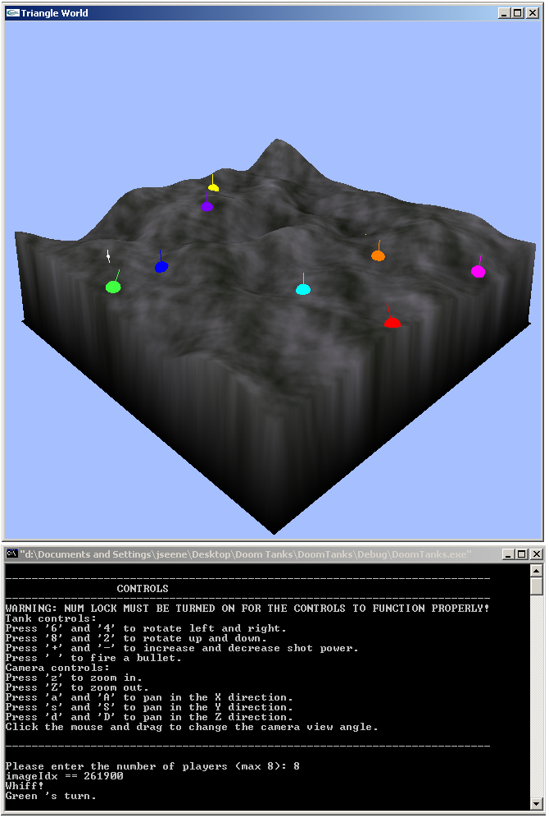
Future Enhancements

There are an almost unlimited number of enhancements that could be added to this game. Some possibilities are listed below:

Strategic tank movement - enable each player to move their tank a small amount during their turn, either before or after firing a bullet. The movement should be tactical, or in other words, incremental based on the triangle resolution of the terrain map.

Player-selected initial start locations - enable players to choose their initial start locations by clicking on the terrain map, and then snapping the player's tank to the nearest grid point. This should probably only be enabled by explicit choice of the players.

Multiple rounds or levels - rather than ending the game after each tank has been destroyed, combine multiple rounds together (compiling the scores) before ending the game. Perhaps change the settings (such as map size, terrain type, terrain variation, tank closeness, etc.) for each new round as well.

Single player mode (target practice) - if 1 player is selected in the "Select number of players phase" the game would go into a single-player mode in which there are some number of tank "targets", or tanks that have no gun and do not get a chance to fire. The player may then take as many shots as they would like in a row at each of the targets. The practice round ends when all the targets have been destroyed, and a printout of the accuracy of the player should be displayed.

Team play - enable teams to be determined, if desired, at the beginning of a round such that friendly bullets will not accidentally kill team member's tanks.

Terrain adjustment by collision - have the explosion from a bullet impacting the terrain cause the terrain to sink slightly in the region in which the bullet hit. In this way, poorly aimed bullets can drastically modify the terrain (over time).

Graphics for tanks, bullets, and explosions - implement cool graphics for the tanks, bullets, and explosions (both terrain and tank explosions) instead of using the default shapes available in basic OpenGL.

Graphical text output - eliminate the need for a console window by outputting all of the relevant game information on the graphical display window, including messages to the players about what is going on in the game (e.g. who has died, whose turn it is, etc.).

Lighting/shadow effects - add lighting and shadow effects to further enhance the graphics of the game, and to add an element of realism.

Chase camera - implement, by player option, a chase camera view that follows a bullet from its inception in the tank barrel to its destination (hopefully an enemy tank!).

Initial camera view behind tanks - at the start of each player's turn, the camera should switch to one of two options (a) where it was located on that player's previous turn or (b) a location behind the tank and looking toward the center of the battlefield.

Weapon variation - include a vast array (or even just more than the status quo of one) of weapons to have each tank select from. Have different types of weapons or ammunition, ranging from short-range highly-explosion bullets to MIRV spread shots to guided shots to terrain altering shots. The more weapons and the more creativity in the weapons, the better the game will be.

